Understanding the explain plan and spark UI

by: Karl Arao

*(best viewed using View -> Web Layout)*

# Troubleshooting workflow

Below is the workflow to know where the time is being spent

* Jobs tab - Job ID will show the high-level Duration
* Jobs tab details - For each Job ID created -> get the breakdown of Stage IDs and check the Duration and Input, Output, Shuffle read and write
* Stages tab - Click on the worst performing Stage ID or the slow Stage IDs and check the Visual Event Timeline, Summary Metrics, and Tasks Duration (check for straggling tasks)
* On two separate tabs, **correlate the Physical Plan ID and visual explain plan** (SQL tab -> click on description URL -> click Details below) with the **DAG details visual execution by Stage ID** (Jobs tab)
  + **Physical Plan ID and visual explain plan** – this is the query plan that shows the join order, join type used, and overall flow of row sources
  + **DAG details visual execution by Stage ID** – this is how Spark job tasks are performed on the cluster
* On SQL tab -> **Physical Plan ID and visual explain plan** -> search for keywords “exchange” and “stage <ID of interest>”
  + “exchange” – this will highlight the shuffle operations on both physical plan and visual explain plan
  + “stage <ID of interest>” – this will allow you to map and highlight the slow DAG stage operation w/ row sources on query plan (what part of the SQL code is slow)
    - It is possible that a join of two row sources will converge on a single stage ID which could be the bottleneck or slowest part of the query

# Key Points

* Focus on TIME and optimize the TIME it takes for the Spark job to run
* DAG is a visual representation of a Spark job (steps performed), this needs to be correlated w/ the physical plan and visual explain plan
* Spark’s optimizer is called “Catalyst”
* Explain plan or Query plan
  + Explain plan can be generated **without executing** the spark job
  + Explain plan or query plan is **only available for DataFrames/Spark SQL**. DAGs show up for ANY job
* Spark UI DAG
  + **Need to execute the spark job**, meaning you have to trigger an action .show()
  + **DAGs show up for ANY job**
  + You can watch the DAGs while running or after job completion
* Shuffle = Stage
  + “Exchange” is a shuffle
  + Number of shuffles = number of stages
* Click on each Stage to see the detailed tasks and plan details
  + Number of tasks = number of partitions of each intermediate dataframe

# Generating explain plan

root@704a9920dffd:/spark/bin# ./spark-shell

**## create times5 dataframe**

scala> val simpleNumbers = spark.range(1,1000)

**simpleNumbers**: **org.apache.spark.sql.Dataset[Long]** = [id: bigint]

scala> val times5 = simpleNumbers.selectExpr("id * 5 as id")

**times5**: **org.apache.spark.sql.DataFrame** = [id: bigint]

scala> times5.explain()

== Physical Plan ==

*(1) Project [(id#0L * 5) AS id#2L]

+- *(1) Range (1, 1000, step=1, splits=4)

**## create moreNumbers dataframe**

scala> val moreNumbers = spark.range(1,5000,2)

**moreNumbers**: **org.apache.spark.sql.Dataset[Long]** = [id: bigint]

**## join the data frames**

scala> val joined = times5.join(moreNumbers, "id")

**joined**: **org.apache.spark.sql.DataFrame** = [id: bigint]

**## generate explain plan – here the join is not yet executed. It needs an action like show()**

scala> joined.explain()

== Physical Plan ==

*(2) Project [id#2L]

+- *(2) BroadcastHashJoin [id#2L], [id#6L], Inner, BuildLeft

:- BroadcastExchange HashedRelationBroadcastMode(List(input[0, bigint, false])), [id=#56]

: +- *(1) Project [(id#0L * 5) AS id#2L]

: +- *(1) Range (1, 1000, step=1, splits=4)

+- *(2) Range (1, 5000, step=2, splits=4)

scala> joined.selectExpr("sum(id)").explain()

== Physical Plan ==

*(3) HashAggregate(keys=[], functions=[sum(id#2L)])

+- Exchange SinglePartition, true, [id=#101]

+- *(2) HashAggregate(keys=[], functions=[partial_sum(id#2L)])

+- *(2) Project [id#2L]

+- *(2) BroadcastHashJoin [id#2L], [id#6L], Inner, BuildLeft

:- BroadcastExchange HashedRelationBroadcastMode(List(input[0, bigint, false])), [id=#95]

: +- *(1) Project [(id#0L * 5) AS id#2L]

: +- *(1) Range (1, 1000, step=1, splits=4)

+- *(2) Range (1, 5000, step=2, splits=4)

## Get type of a variable

scala> sum_two.getClass

**res12**: **Class[_ <: org.apache.spark.sql.DataFrame]** = class org.apache.spark.sql.Dataset

scala> times5.getClass

**res13**: **Class[_ <: org.apache.spark.sql.DataFrame]** = class org.apache.spark.sql.Dataset

scala> simpleNumbers.getClass

**res14**: **Class[_ <: org.apache.spark.sql.Dataset[Long]]** = class org.apache.spark.sql.Dataset

scala> joined.getClass

**res15**: **Class[_ <: org.apache.spark.sql.DataFrame]** = class org.apache.spark.sql.Dataset

**## this is an RDD**

scala> parallel1000.getClass

**res16**: **Class[Long]** = long

# Generate explain and execute

scala> val sum_two = joined.selectExpr("sum(id)")

**sum_two**: **org.apache.spark.sql.DataFrame** = [sum(id): bigint]

**## this will execute the job**

scala> sum_two.show()

+-------+

|sum(id)|

+-------+

|1250000|

+-------+

**## generate only the physical plan**

scala> sum_two.explain()

== Physical Plan ==

*(3) HashAggregate(keys=[], functions=[sum(id#2L)])

+- Exchange SinglePartition, true, [id=#194]

+- *(2) HashAggregate(keys=[], functions=[partial_sum(id#2L)])

+- *(2) Project [id#2L]

+- *(2) BroadcastHashJoin [id#2L], [id#6L], Inner, BuildLeft

:- BroadcastExchange HashedRelationBroadcastMode(List(input[0, bigint, false])), [id=#188]

: +- *(1) Project [(id#0L * 5) AS id#2L]

: +- *(1) Range (1, 1000, step=1, splits=4)

+- *(2) Range (1, 5000, step=2, splits=4)

**## generate the logical (extended=true) and physical plan**

scala> sum_two.explain(extended=true)

== Parsed Logical Plan ==

'Project [unresolvedalias('sum('id), Some(org.apache.spark.sql.Column$$Lambda$2324/1825090914@49cb7d64))]

+- Project [id#2L]

+- Join Inner, (id#2L = id#6L)

:- Project [(id#0L * cast(5 as bigint)) AS id#2L]

: +- Range (1, 1000, step=1, splits=Some(4))

+- Range (1, 5000, step=2, splits=Some(4))

== Analyzed Logical Plan ==

sum(id): bigint

Aggregate [sum(id#2L) AS sum(id)#20L]

+- Project [id#2L]

+- Join Inner, (id#2L = id#6L)

:- Project [(id#0L * cast(5 as bigint)) AS id#2L]

: +- Range (1, 1000, step=1, splits=Some(4))

+- Range (1, 5000, step=2, splits=Some(4))

== Optimized Logical Plan ==

Aggregate [sum(id#2L) AS sum(id)#20L]

+- Project [id#2L]

+- Join Inner, (id#2L = id#6L)

:- Project [(id#0L * 5) AS id#2L]

: +- Range (1, 1000, step=1, splits=Some(4))

+- Range (1, 5000, step=2, splits=Some(4))

== Physical Plan ==

*(3) HashAggregate(keys=[], functions=[sum(id#2L)], output=[sum(id)#20L])

+- Exchange SinglePartition, true, [id=#194]

+- *(2) HashAggregate(keys=[], functions=[partial_sum(id#2L)], output=[sum#26L])

+- *(2) Project [id#2L]

+- *(2) BroadcastHashJoin [id#2L], [id#6L], Inner, BuildLeft

:- BroadcastExchange HashedRelationBroadcastMode(List(input[0, bigint, false])), [id=#188]

: +- *(1) Project [(id#0L * 5) AS id#2L]

: +- *(1) Range (1, 1000, step=1, splits=4)

+- *(2) Range (1, 5000, step=2, splits=4)

# Explaining the text explain plan

* Read the indentations like an Oracle execution plan
* Physical Plan IDs *(1) * (2) *(3) maps to the Stage IDs of the DAG
* “Exchange“ - means a shuffle happened which is an expensive operation in spark world

scala> sum_two.explain()

== Physical Plan ==

*(3) HashAggregate(keys=[], functions=[sum(id#2L)])

+- Exchange SinglePartition, true, [id=#194]

+- *(2) HashAggregate(keys=[], functions=[partial_sum(id#2L)])

+- *(2) Project [id#2L]

+- *(2) BroadcastHashJoin [id#2L], [id#6L], Inner, BuildLeft

:- BroadcastExchange HashedRelationBroadcastMode(List(input[0, bigint, false])), [id=#188]

: +- *(1) Project [(id#0L * 5) AS id#2L]

: +- *(1) Range (1, 1000, step=1, splits=4)

+- *(2) Range (1, 5000, step=2, splits=4)

# Exploring spark-ui explain plan

* Access spark-ui
  + http://localhost:4040/jobs/

## Simple count on RDD

scala> sc.parallelize(1 to 1000).count()

### Jobs

* Job ID is sorted DESC (highest is the most recent). Focus on Submitted column for the grouping of Job IDs
* the :24 means the specific line of code this behaves like the Oracle SQL_PLAN_LINE_ID

count at <console>:24

* Click on the link

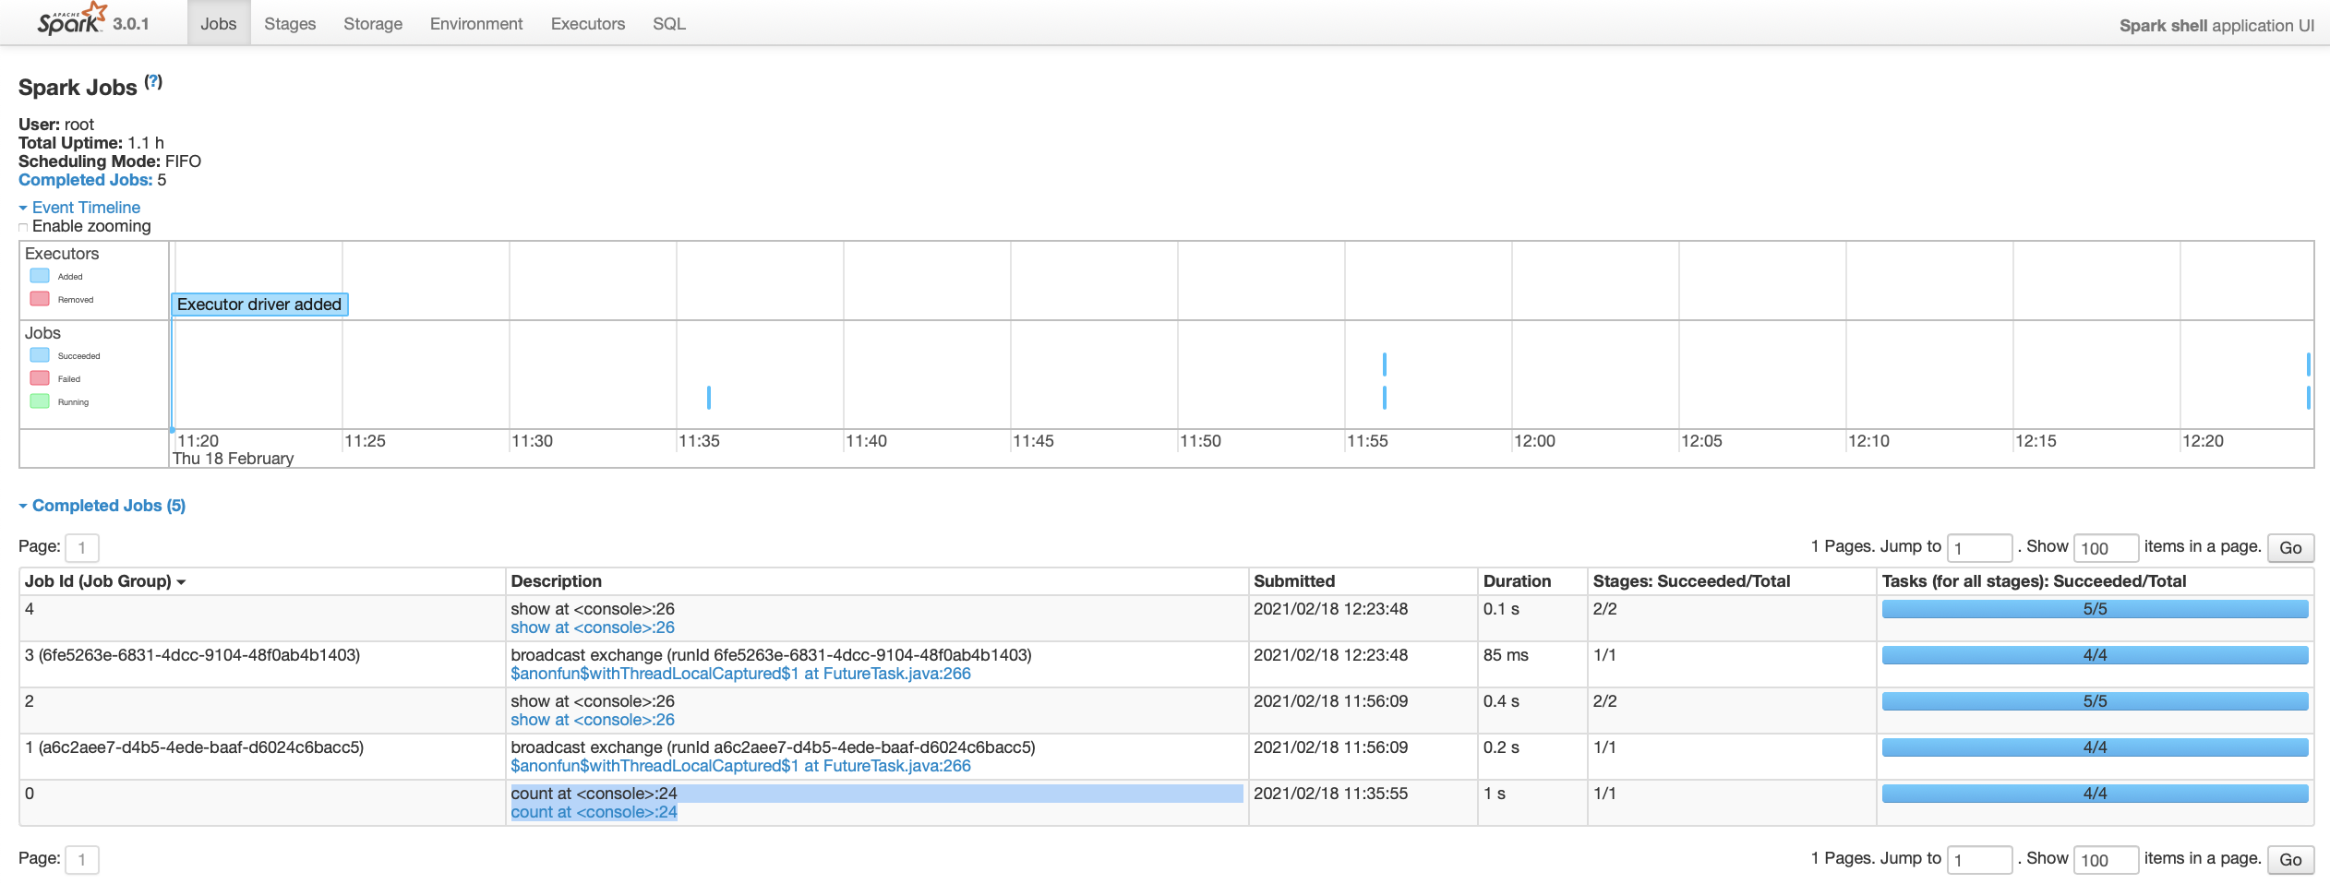

### DAGs or Stages

* Clicking on the link shows the DAG visualization
* Clicking on each DAG visualization or stages link will drill down to tasks

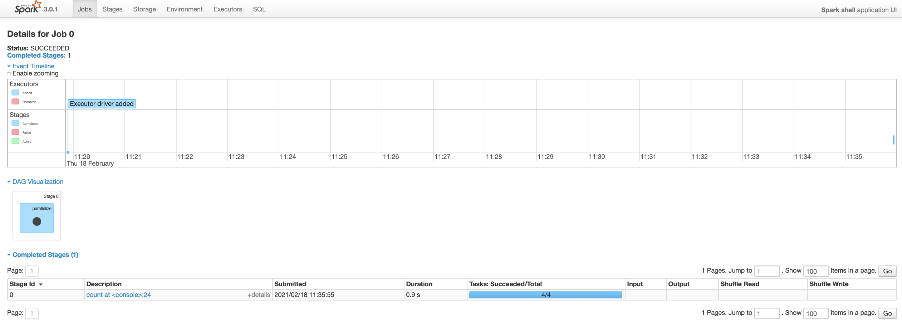

### Tasks

* This page shows the detailed elapsed time breakdown of tasks
  + Here you’ll be able to find the straggling tasks or skewness of elapsed time to a particular task due to serialization or data skewness
* Tasks are spawned by Executor
* Tasks are like PX slaves in Oracle and Executors are like QC coordinator
* Event Timeline shows the breakdown of time by task

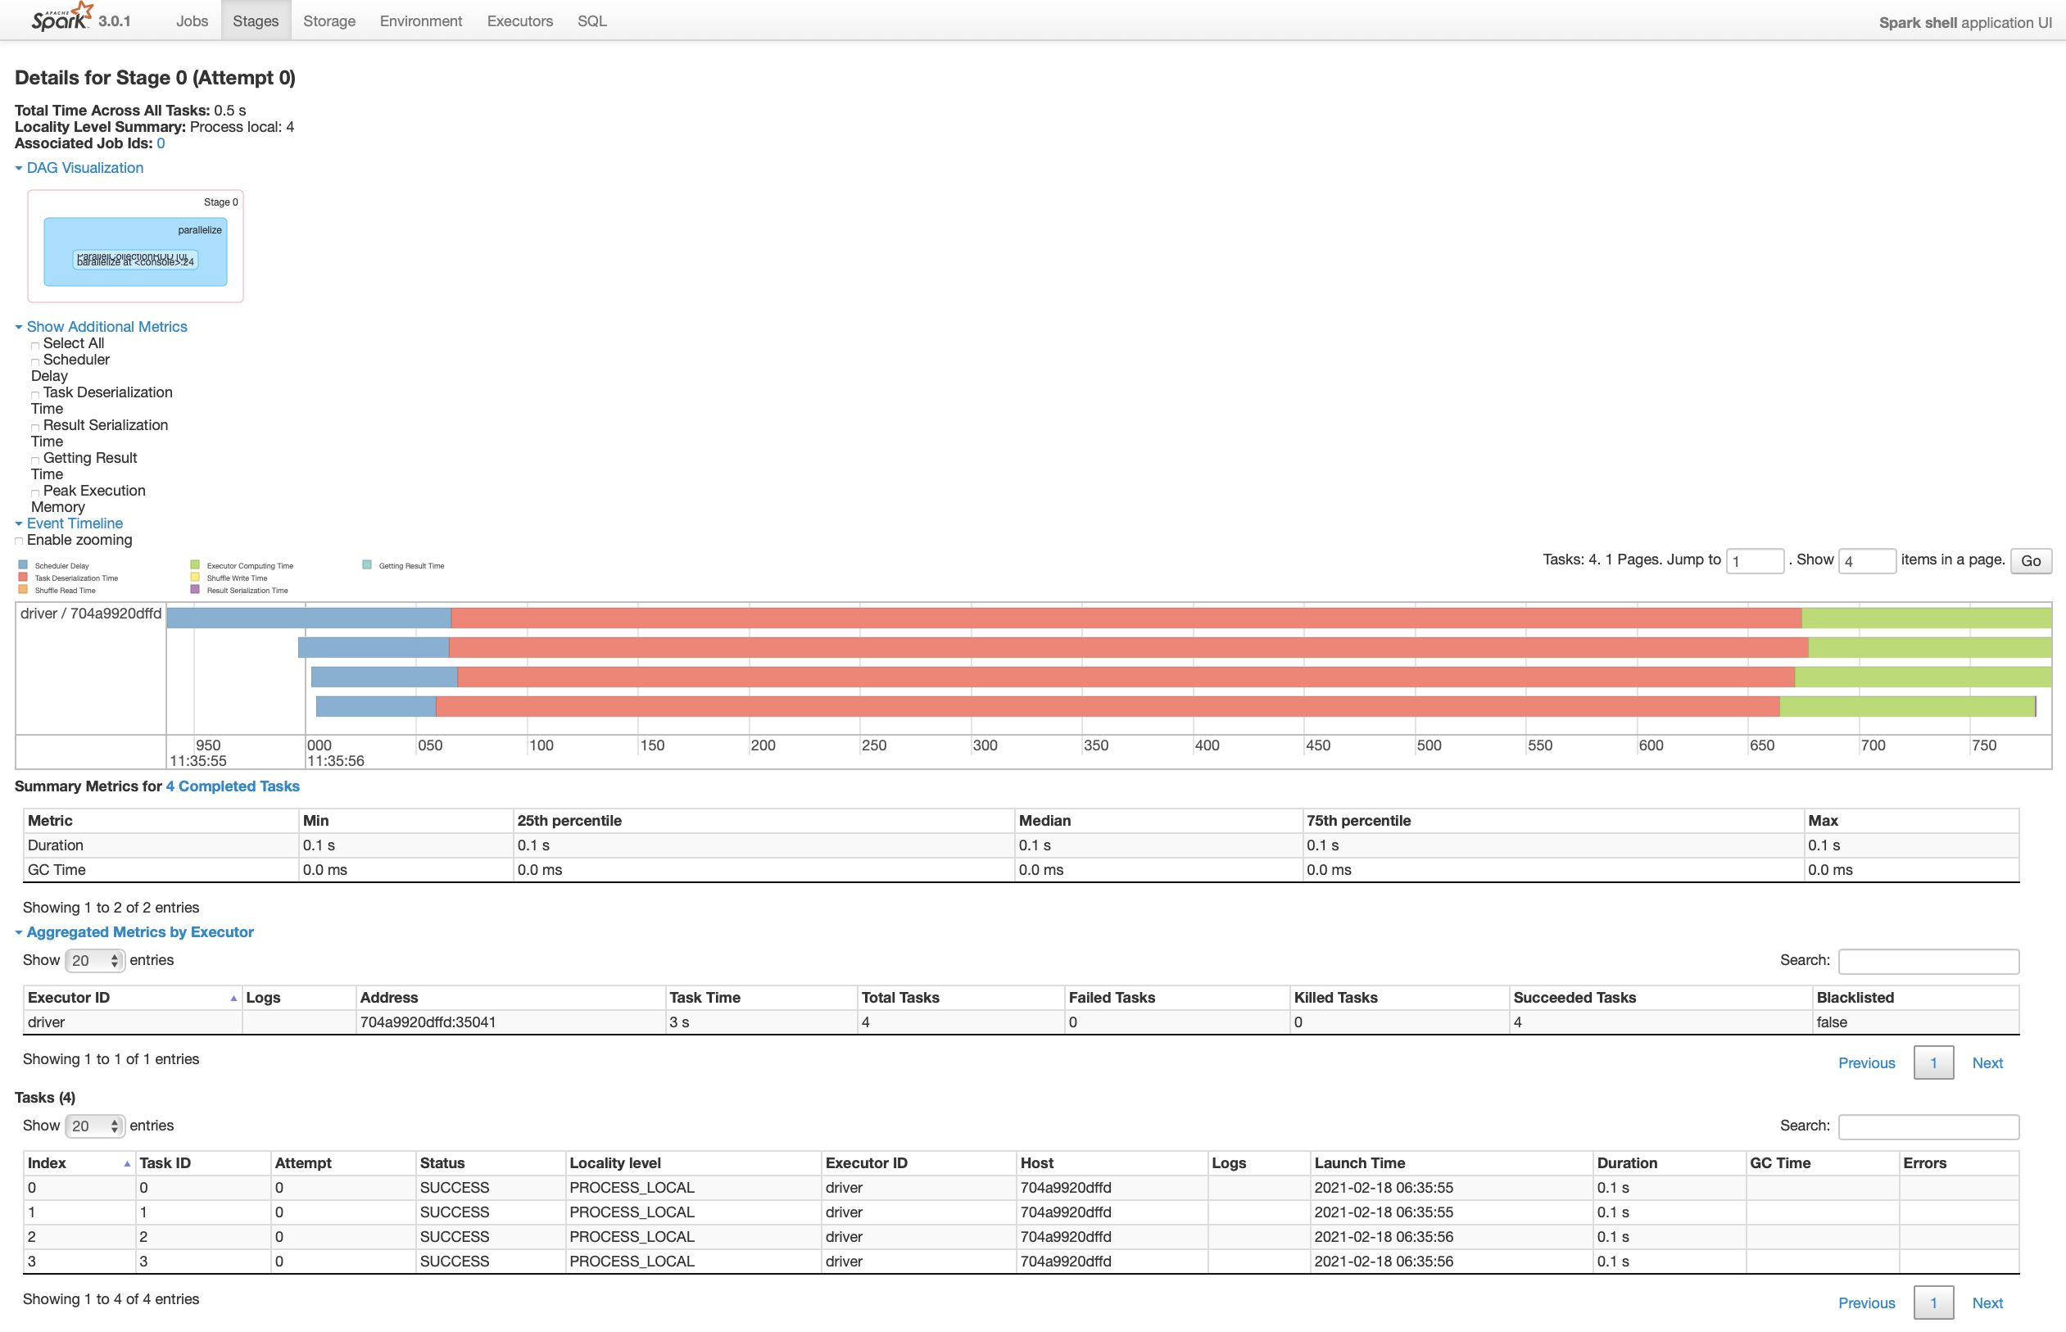

### Stages Summary

* Clicking the Stages tab shows the high-level Duration, Input, Output, Shuffle Read and Write
* This is just another view of the Stage ID breakdown, focus on Submitted column for the grouping on Job ID level

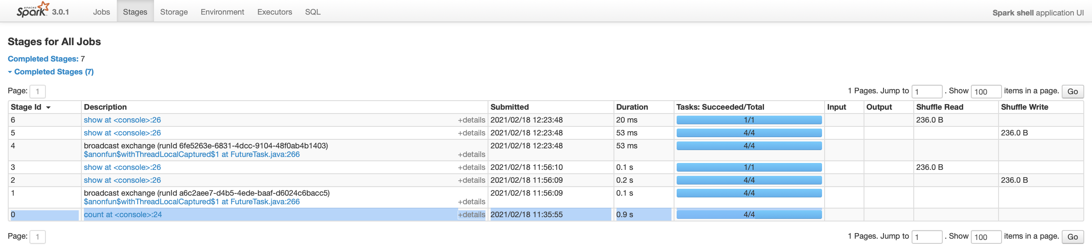

### Storage

* This page shows the memory footprint of the objects



### Environment

* Runtime and Environment details

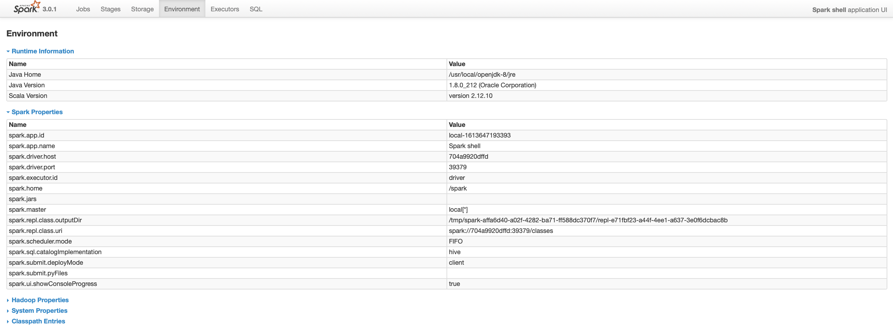

### Executors

* Executors summary and detailed statistics

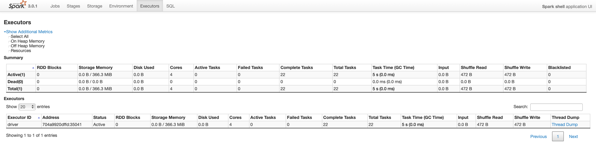

### SQL

* Not related to RDDs, these are the spark SQL jobs executed

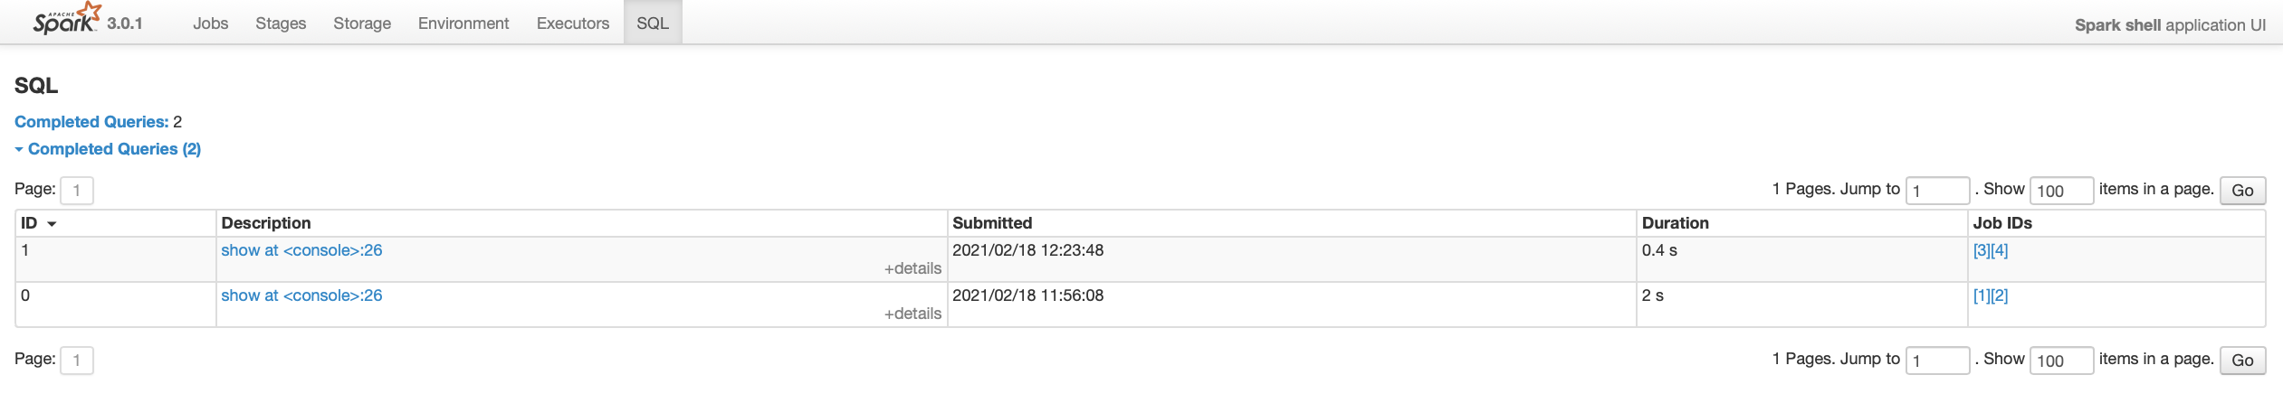

## DataFrame join and sum – Spark SQL

**## create times5 dataframe**

scala> val simpleNumbers = spark.range(1,1000)

**simpleNumbers**: **org.apache.spark.sql.Dataset[Long]** = [id: bigint]

scala> val times5 = simpleNumbers.selectExpr("id * 5 as id")

**times5**: **org.apache.spark.sql.DataFrame** = [id: bigint]

**## create moreNumbers dataframe**

scala> val moreNumbers = spark.range(1,5000,2)

**moreNumbers**: **org.apache.spark.sql.Dataset[Long]** = [id: bigint]

**## join the data frames**

scala> val joined = times5.join(moreNumbers, "id")

**joined**: **org.apache.spark.sql.DataFrame** = [id: bigint]

scala> val sum_two = joined.selectExpr("sum(id)")

**sum_two**: **org.apache.spark.sql.DataFrame** = [sum(id): bigint]

**## this will execute the job**

scala> sum_two.show()

+-------+

|sum(id)|

+-------+

|1250000|

+-------+

### Jobs

* The action sum_two.show() generated the Job ID 1 and 2 below (highlighted below)
* Job ID is sorted DESC (highest is the most recent). Focus on Submitted column for the grouping of Job IDs
* The Job ID 3 and 4 are re-execution of the variable sum_two hence the same line id :26, also notice the faster duration (cached result)

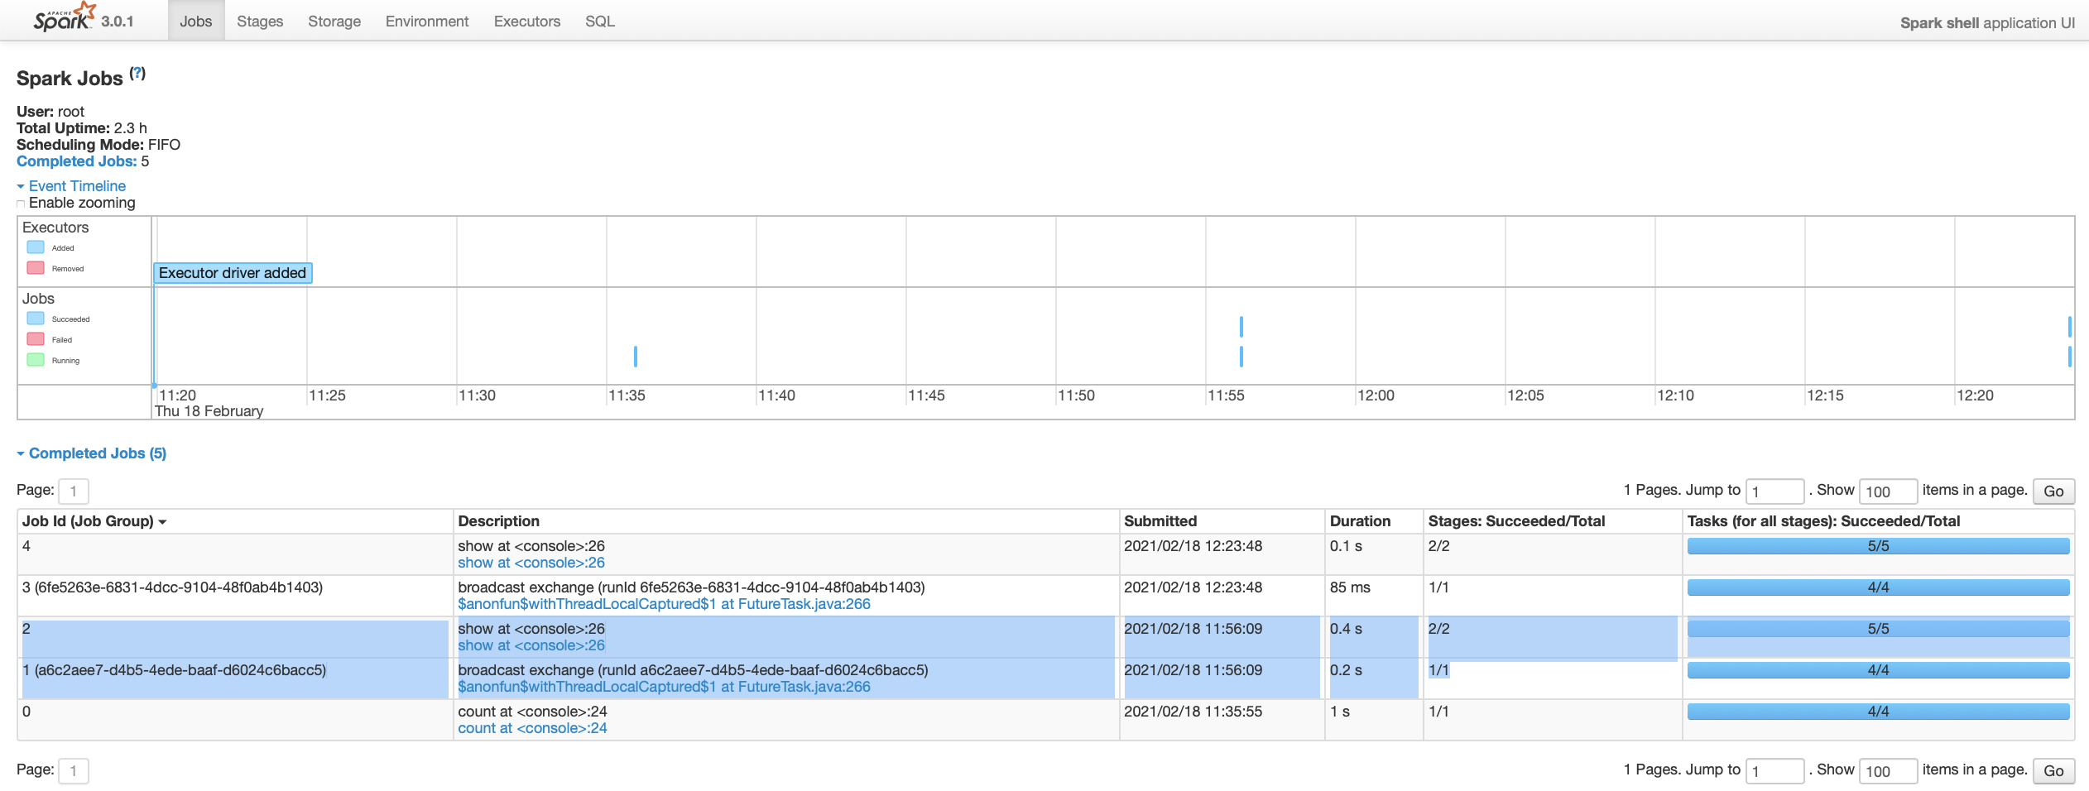

### DAGs or Stages

#### Job ID 1

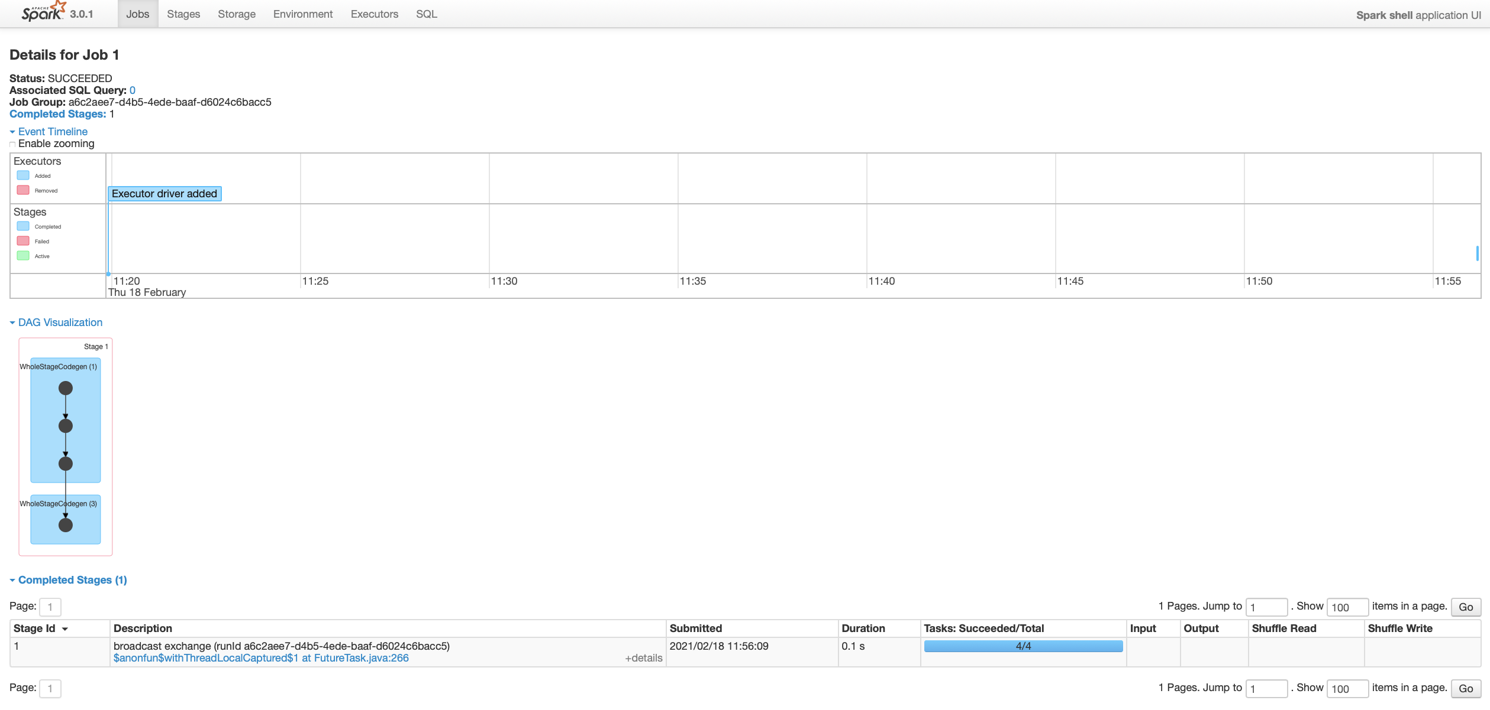

#### Job ID 2

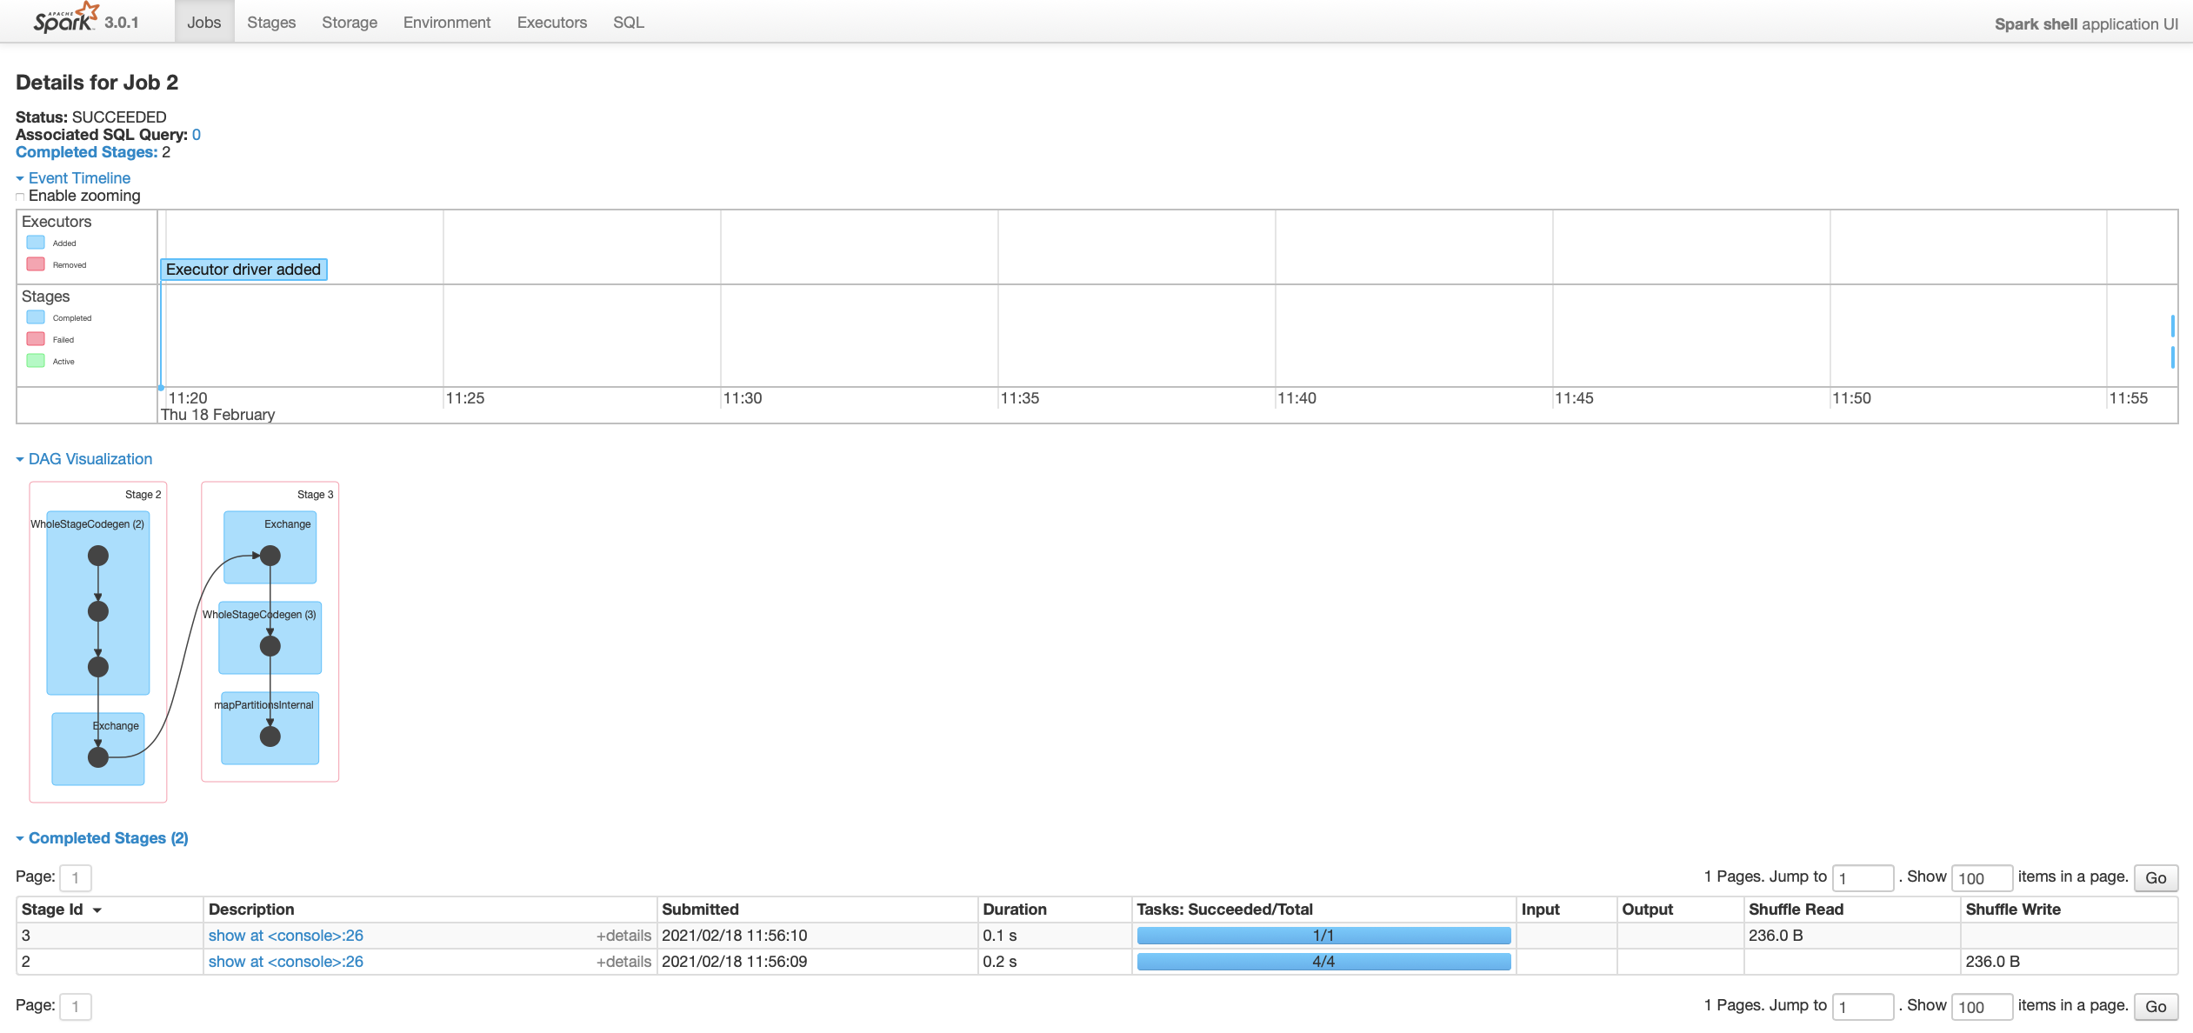

### Tasks

#### Job ID 1 - Stage 1

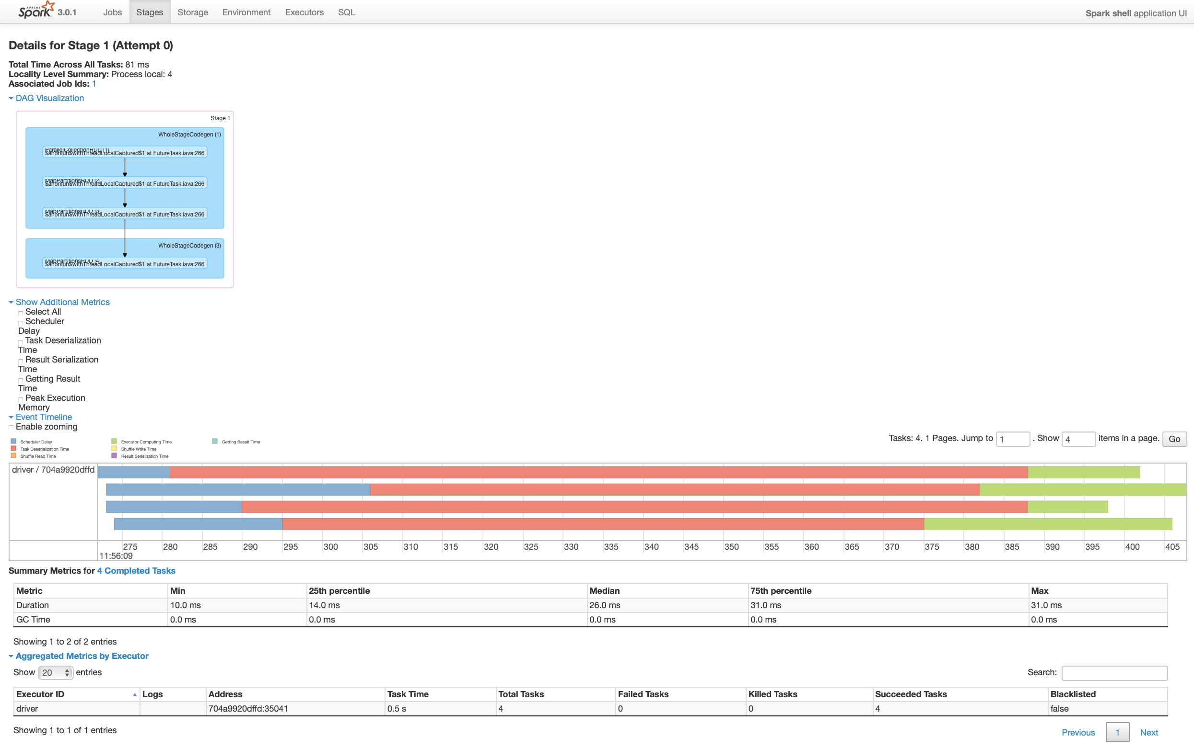

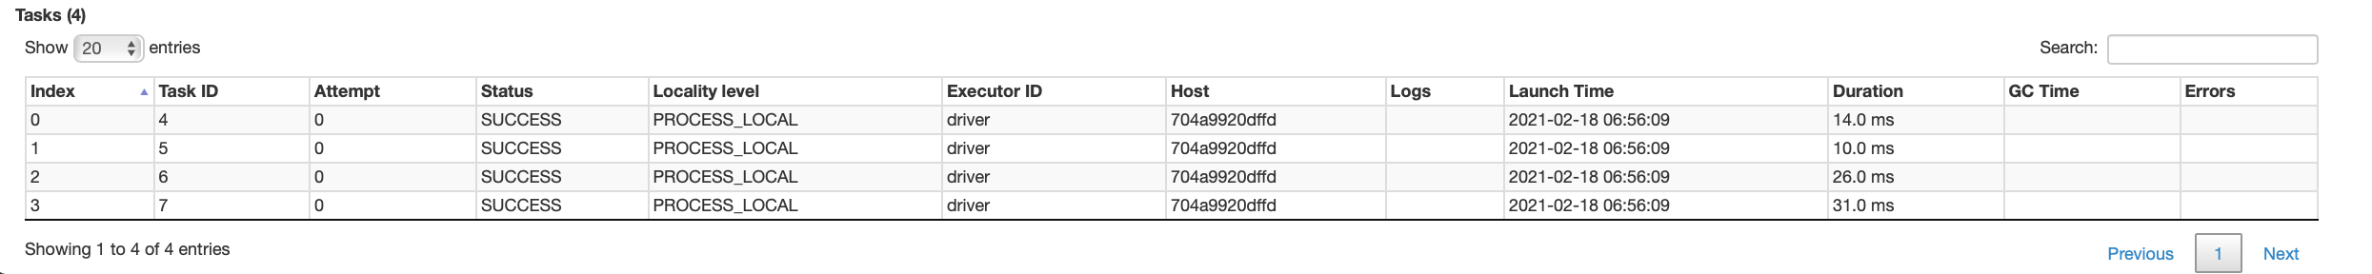

#### Job ID 2 - Stage 2

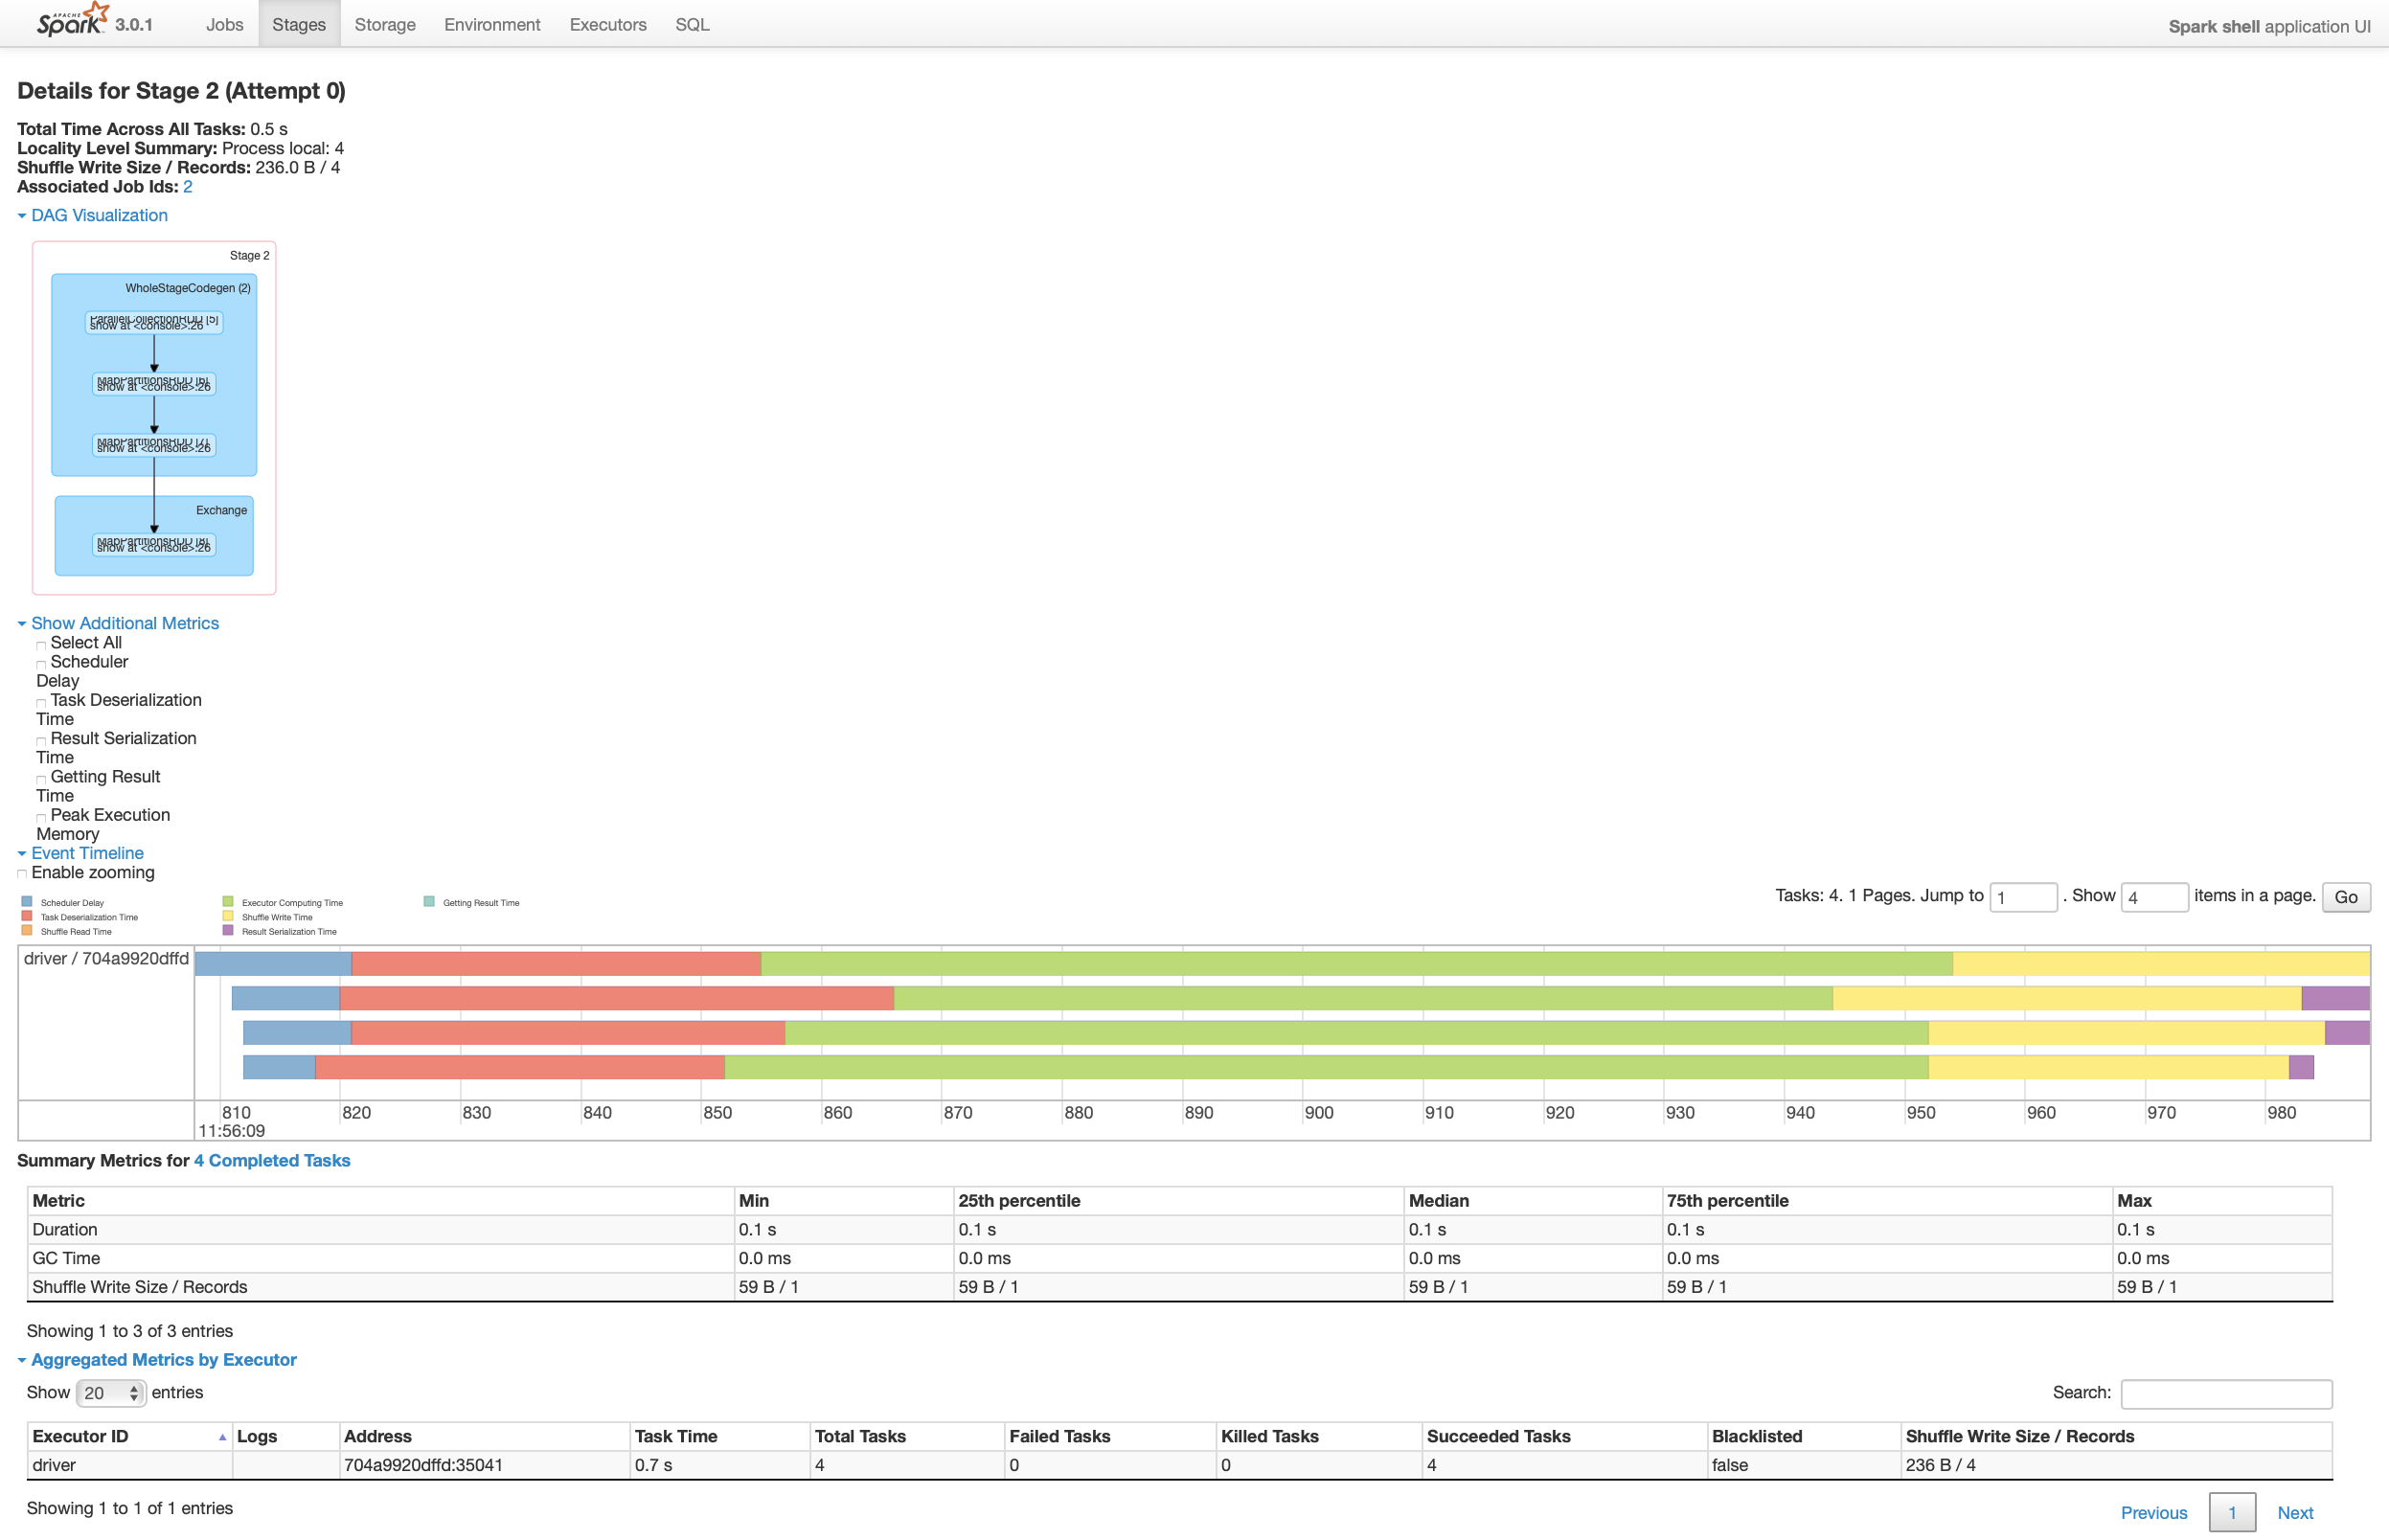

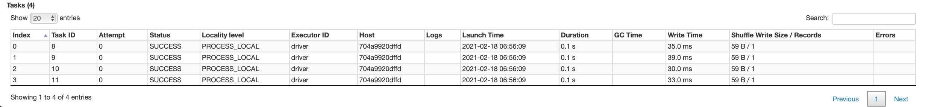

#### Job ID 2 - Stage 3

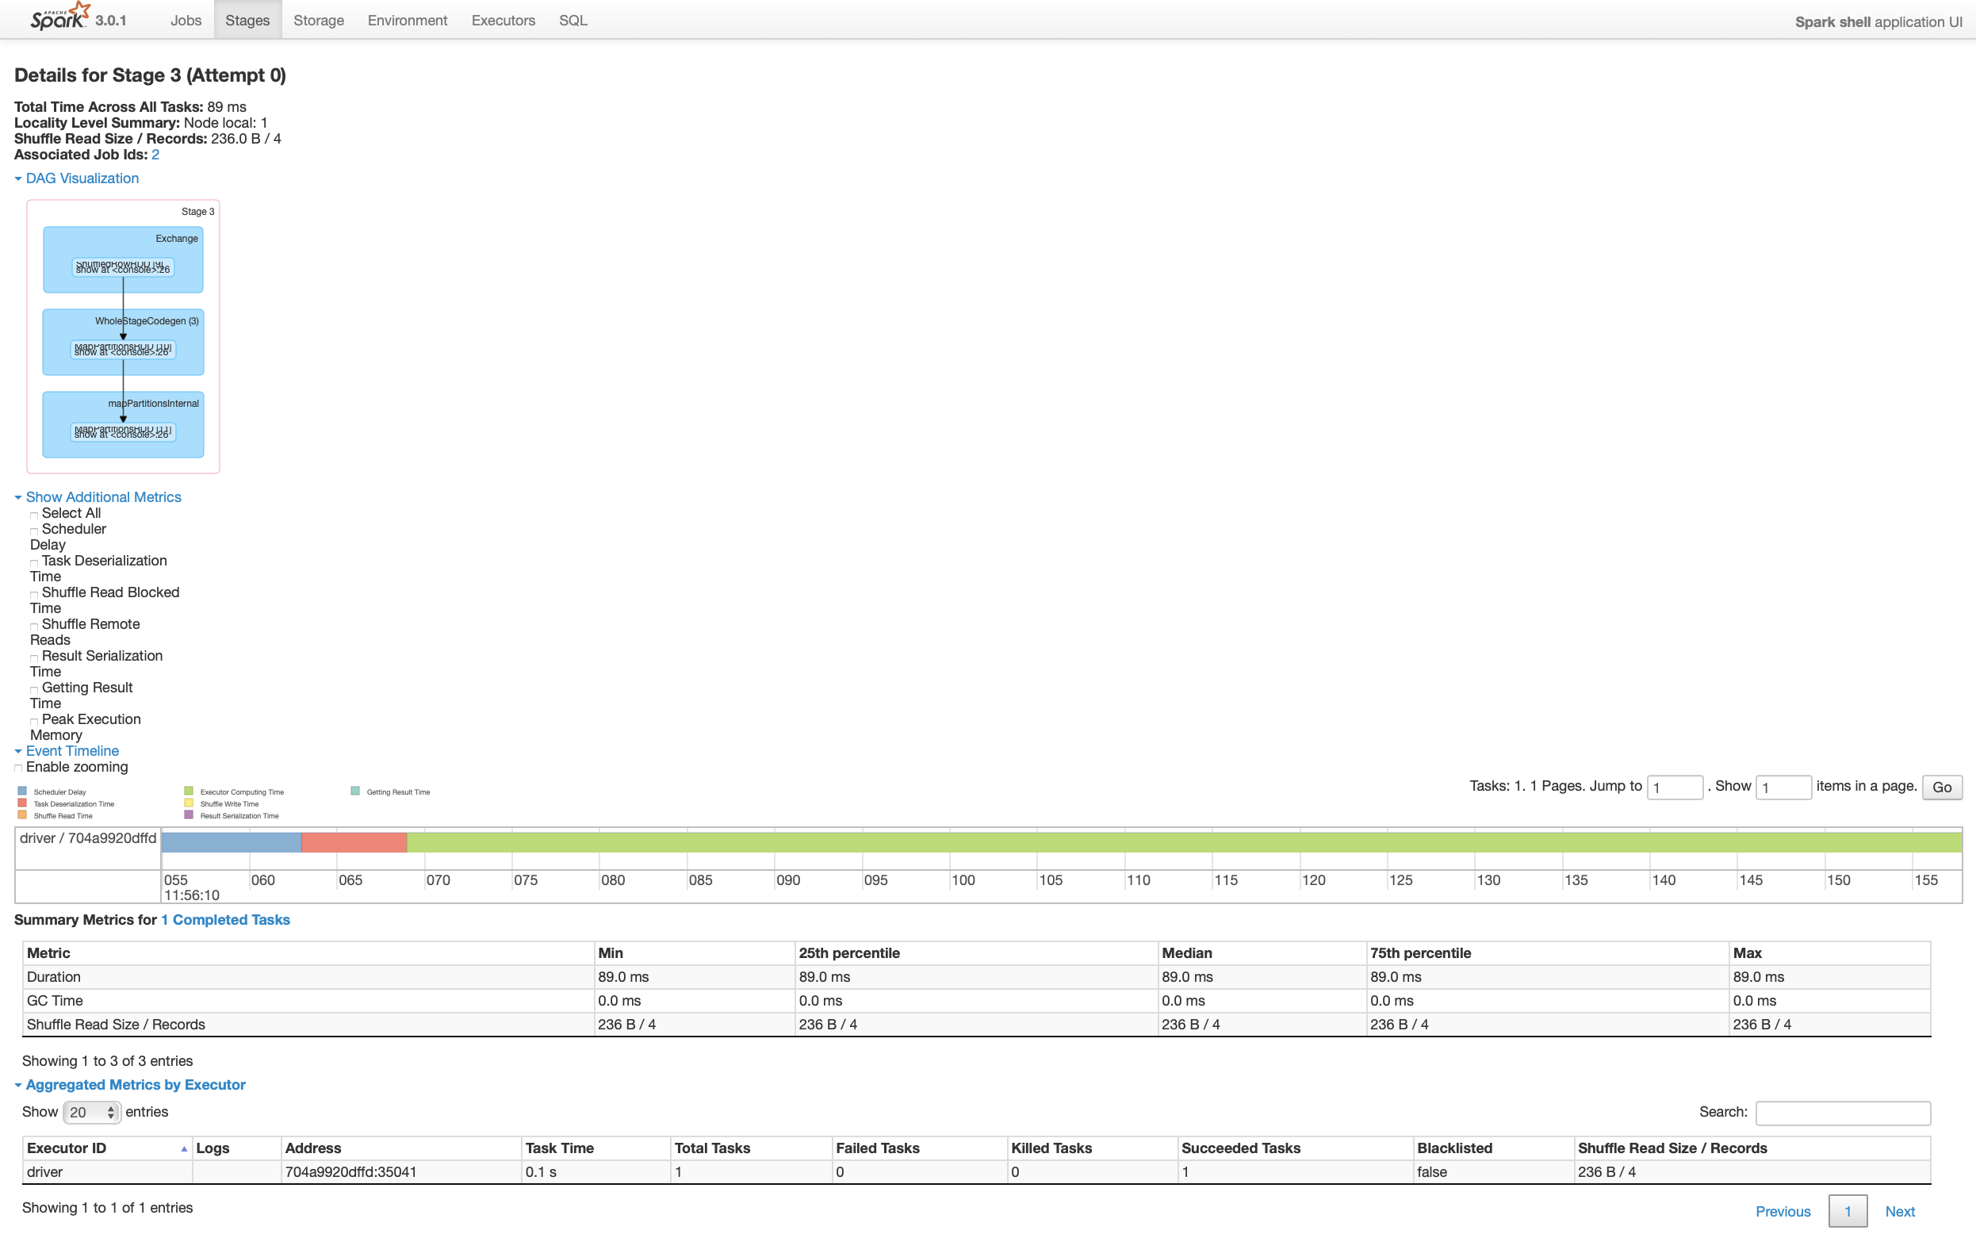



### Stages Summary

* Clicking the Stages tab shows the high-level Duration, Input, Output, Shuffle Read and Write
* This is just another view of the Stage ID breakdown, focus on Submitted column for the grouping on Job ID level

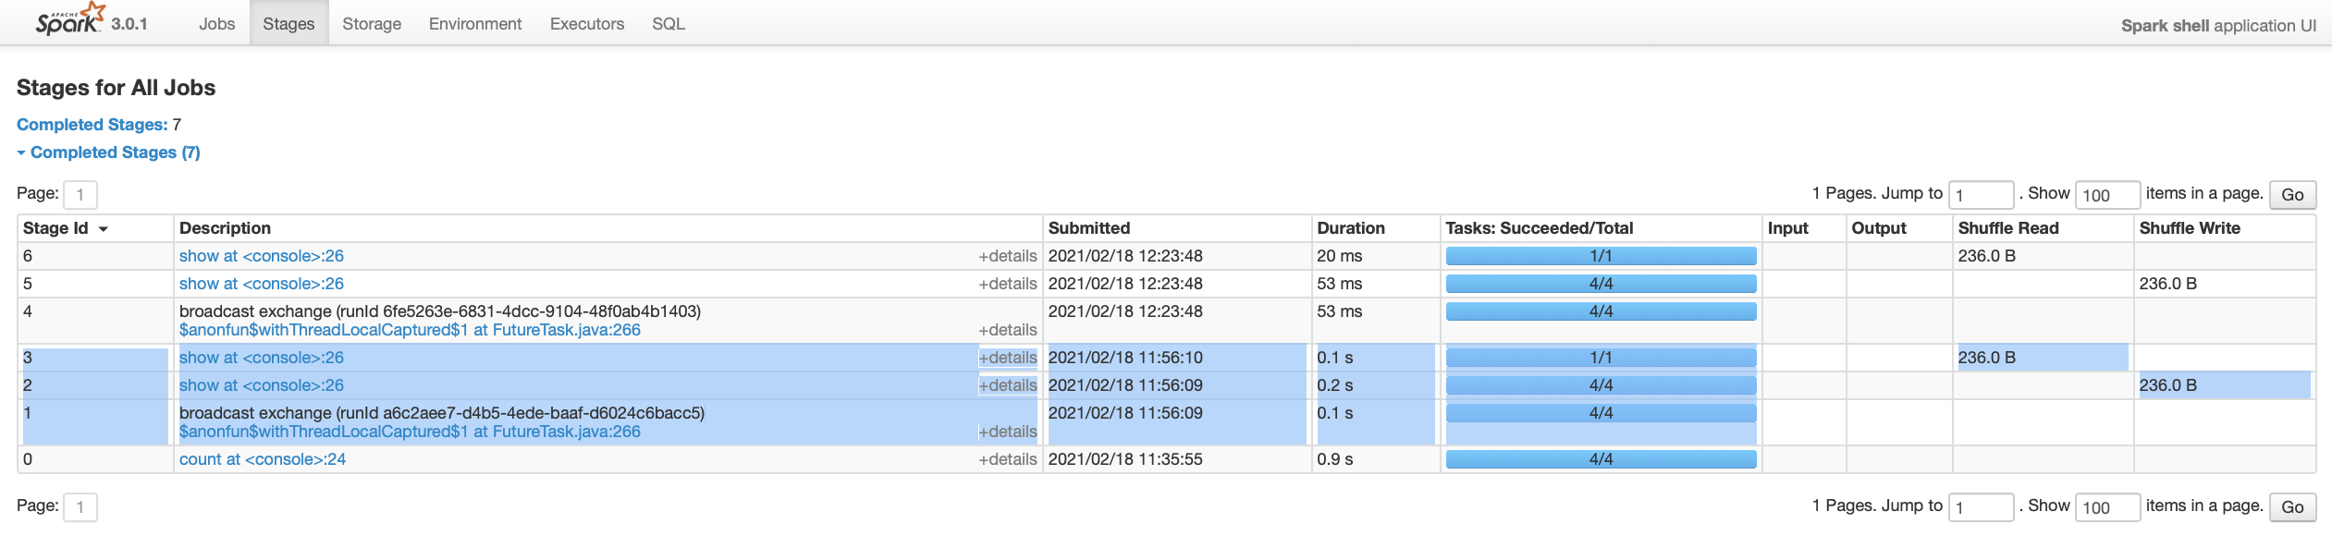

### Storage

* This page shows the memory footprint of the objects



### Environment

* Runtime and Environment details



### Executors

* Executors summary and detailed statistics



### SQL

#### SQL tab

* This test case is related to ID 0 -> click on Description link
* Also notice the related Job IDs [1] [2] at the very end (contains the Stage IDs [1] [2] [3])



#### Visual and Physical Explain Plan

* For Spark SQL jobs, this will allow you to map and highlight the slow DAG stage operation w/ row sources on query plan (what part of the SQL code is slow)

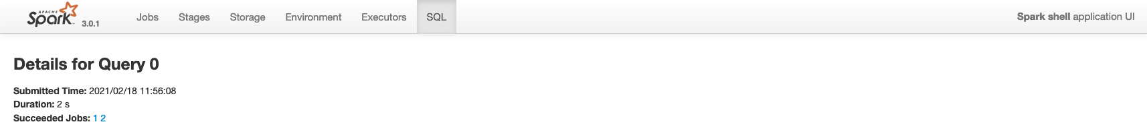

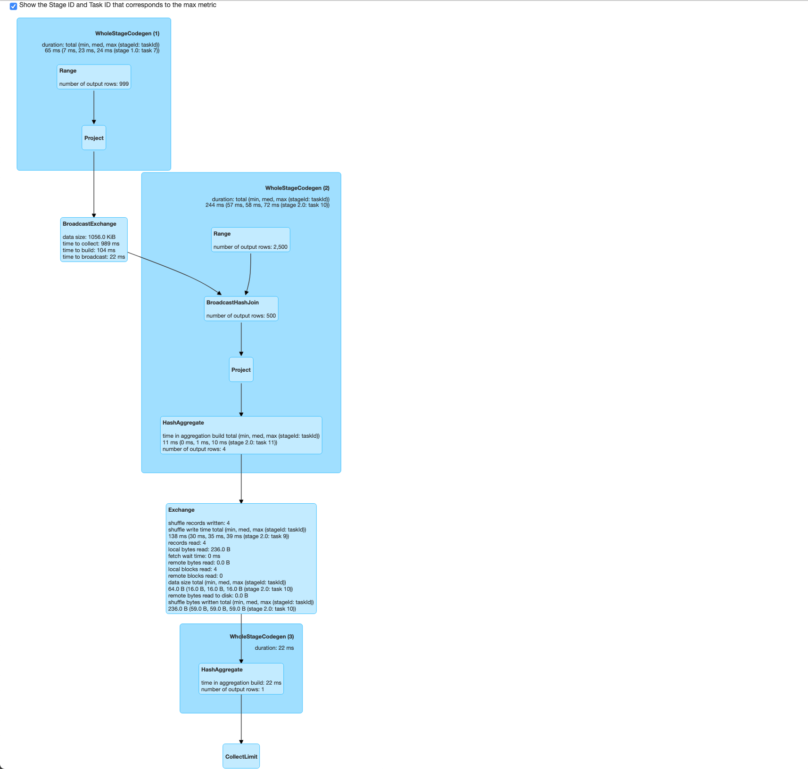

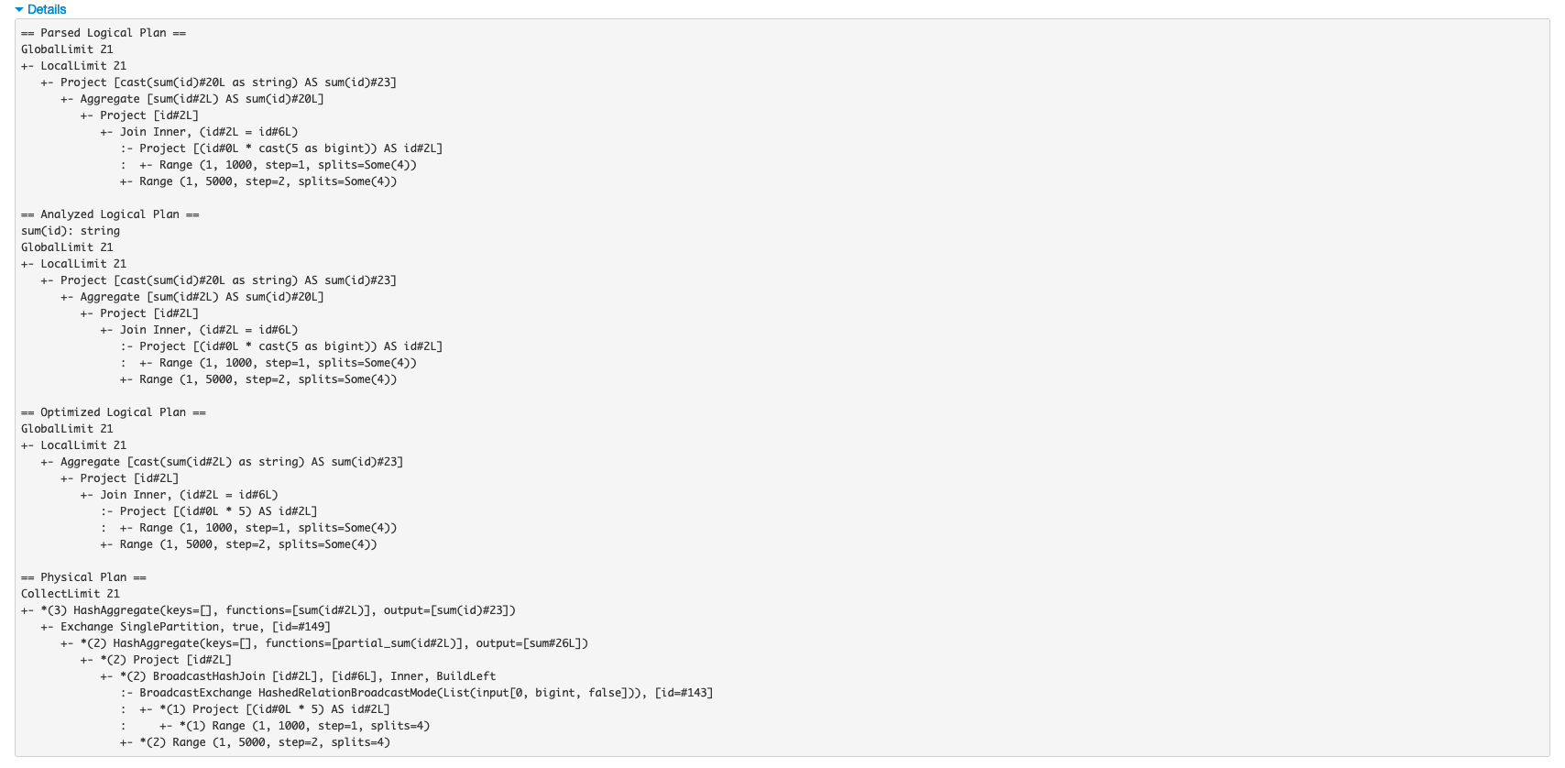

**## generate only the physical plan**

scala> sum_two.explain()

== Physical Plan ==

*(3) HashAggregate(keys=[], functions=[sum(id#2L)])

+- Exchange SinglePartition, true, [id=#194]

+- *(2) HashAggregate(keys=[], functions=[partial_sum(id#2L)])

+- *(2) Project [id#2L]

+- *(2) BroadcastHashJoin [id#2L], [id#6L], Inner, BuildLeft

:- BroadcastExchange HashedRelationBroadcastMode(List(input[0, bigint, false])), [id=#188]

: +- *(1) Project [(id#0L * 5) AS id#2L]

: +- *(1) Range (1, 1000, step=1, splits=4)

+- *(2) Range (1, 5000, step=2, splits=4)

### Correlating the DAG with Visual Explain Plan

* The blue circle and lines are the Exchange or Shuffle operations. The lines show the relationship of shuffles across Query Plan ID and DAG Stage ID
* The red circle and lines show the mapping of DAG “Stage 2” (the slowest of all DAGs) to the Query “Plan ID 2” + “Exchange SinglePartition”

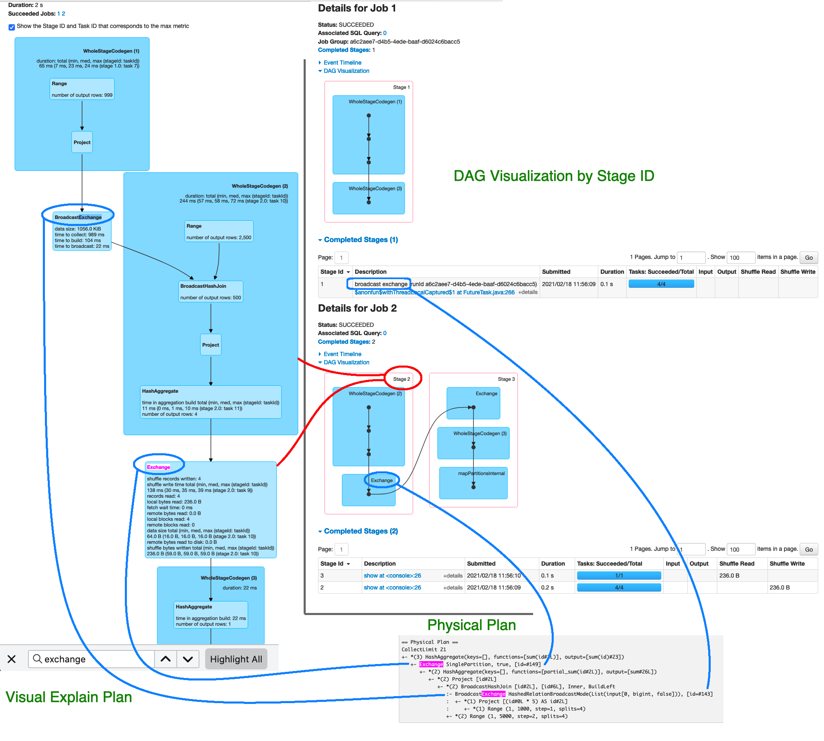

## Re-execution (cached result) comparison

* This shows the effect of cached result to the elapsed time – 2s vs 0.4s (cached)
* Stage 2 and 5 are the expensive operations
* Overall shorter
  + Task Deserialization Time
  + Executor Computing Time
  + Shuffle Write Time

### Summary

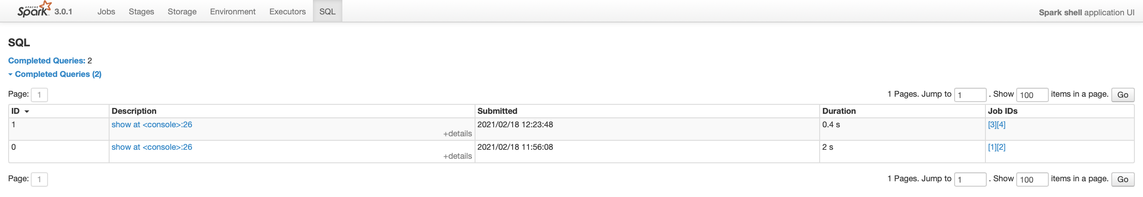

### Initial execution

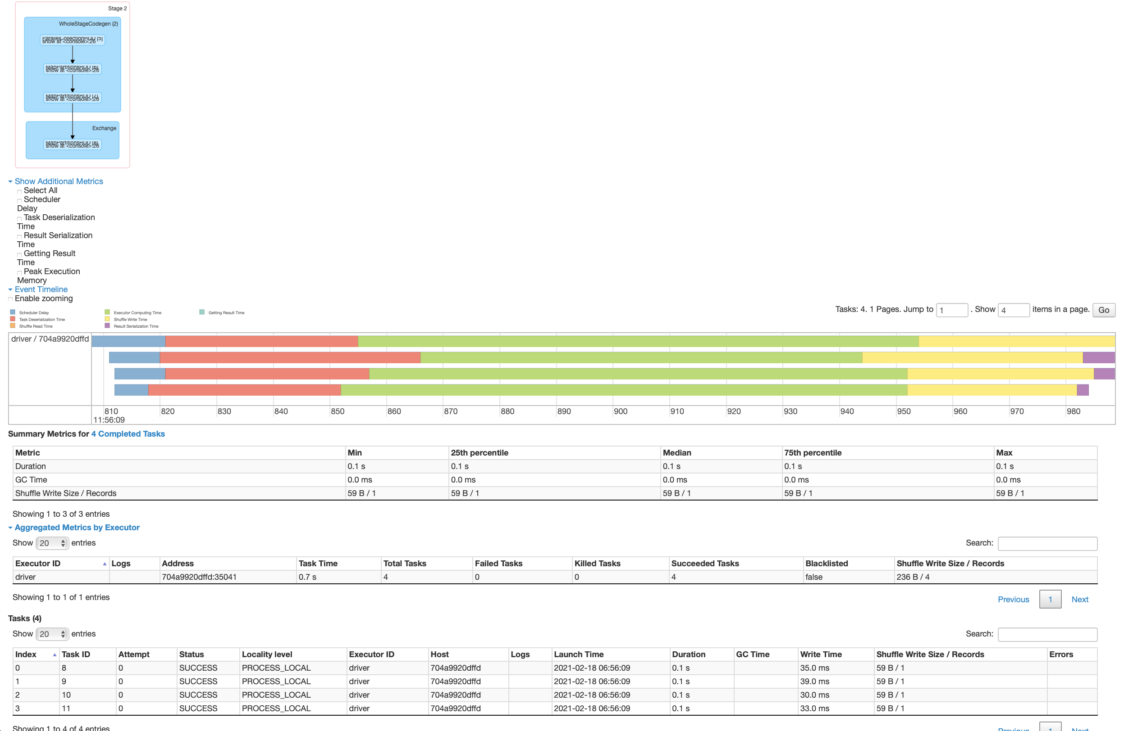

### 2nd execution

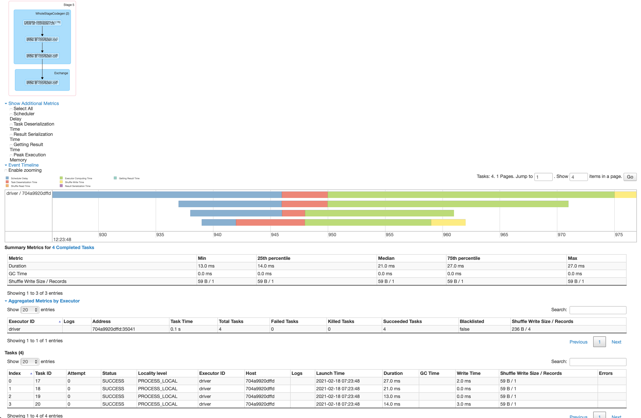

## Complex DataFrame join and sum – Spark SQL

scala> val ds1 = spark.range(1, 10000000)

**ds1**: **org.apache.spark.sql.Dataset[Long]** = [id: bigint]

scala> val ds2 = spark.range(1, 20000000, 2)

**ds2**: **org.apache.spark.sql.Dataset[Long]** = [id: bigint]

scala> val ds3 = ds1.repartition(7)

**ds3**: **org.apache.spark.sql.Dataset[Long]** = [id: bigint]

scala> val ds4 = ds2.repartition(9)

**ds4**: **org.apache.spark.sql.Dataset[Long]** = [id: bigint]

scala> val ds5 = ds3.selectExpr("id * 3 as id")

**ds5**: **org.apache.spark.sql.DataFrame** = [id: bigint]

scala> val joined = ds5.join(ds4, "id")

**joined**: **org.apache.spark.sql.DataFrame** = [id: bigint]

scala> val sum = joined.selectExpr("sum(id)")

**sum**: **org.apache.spark.sql.DataFrame** = [sum(id): bigint]

scala> sum.explain()

== Physical Plan ==

*(7) HashAggregate(keys=[], functions=[sum(id#42L)])

+- Exchange SinglePartition, true, [id=#313]

+- *(6) HashAggregate(keys=[], functions=[partial_sum(id#42L)])

+- *(6) Project [id#42L]

+- *(6) SortMergeJoin [id#42L], [id#36L], Inner

:- *(3) Sort [id#42L ASC NULLS FIRST], false, 0

: +- Exchange hashpartitioning(id#42L, 200), true, [id=#297]

: +- *(2) Project [(id#34L * 3) AS id#42L]

: +- Exchange RoundRobinPartitioning(7), false, [id=#293]

: +- *(1) Range (1, 10000000, step=1, splits=4)

+- *(5) Sort [id#36L ASC NULLS FIRST], false, 0

+- Exchange hashpartitioning(id#36L, 200), true, [id=#304]

+- Exchange RoundRobinPartitioning(9), false, [id=#303]

+- *(4) Range (1, 20000000, step=2, splits=4)

scala> sum.show()

+--------------+

| sum(id)|

+--------------+

|33333326666667|

+--------------+

### Jobs

* 22 seconds Duration
* 6 Stages
* 225 Tasks

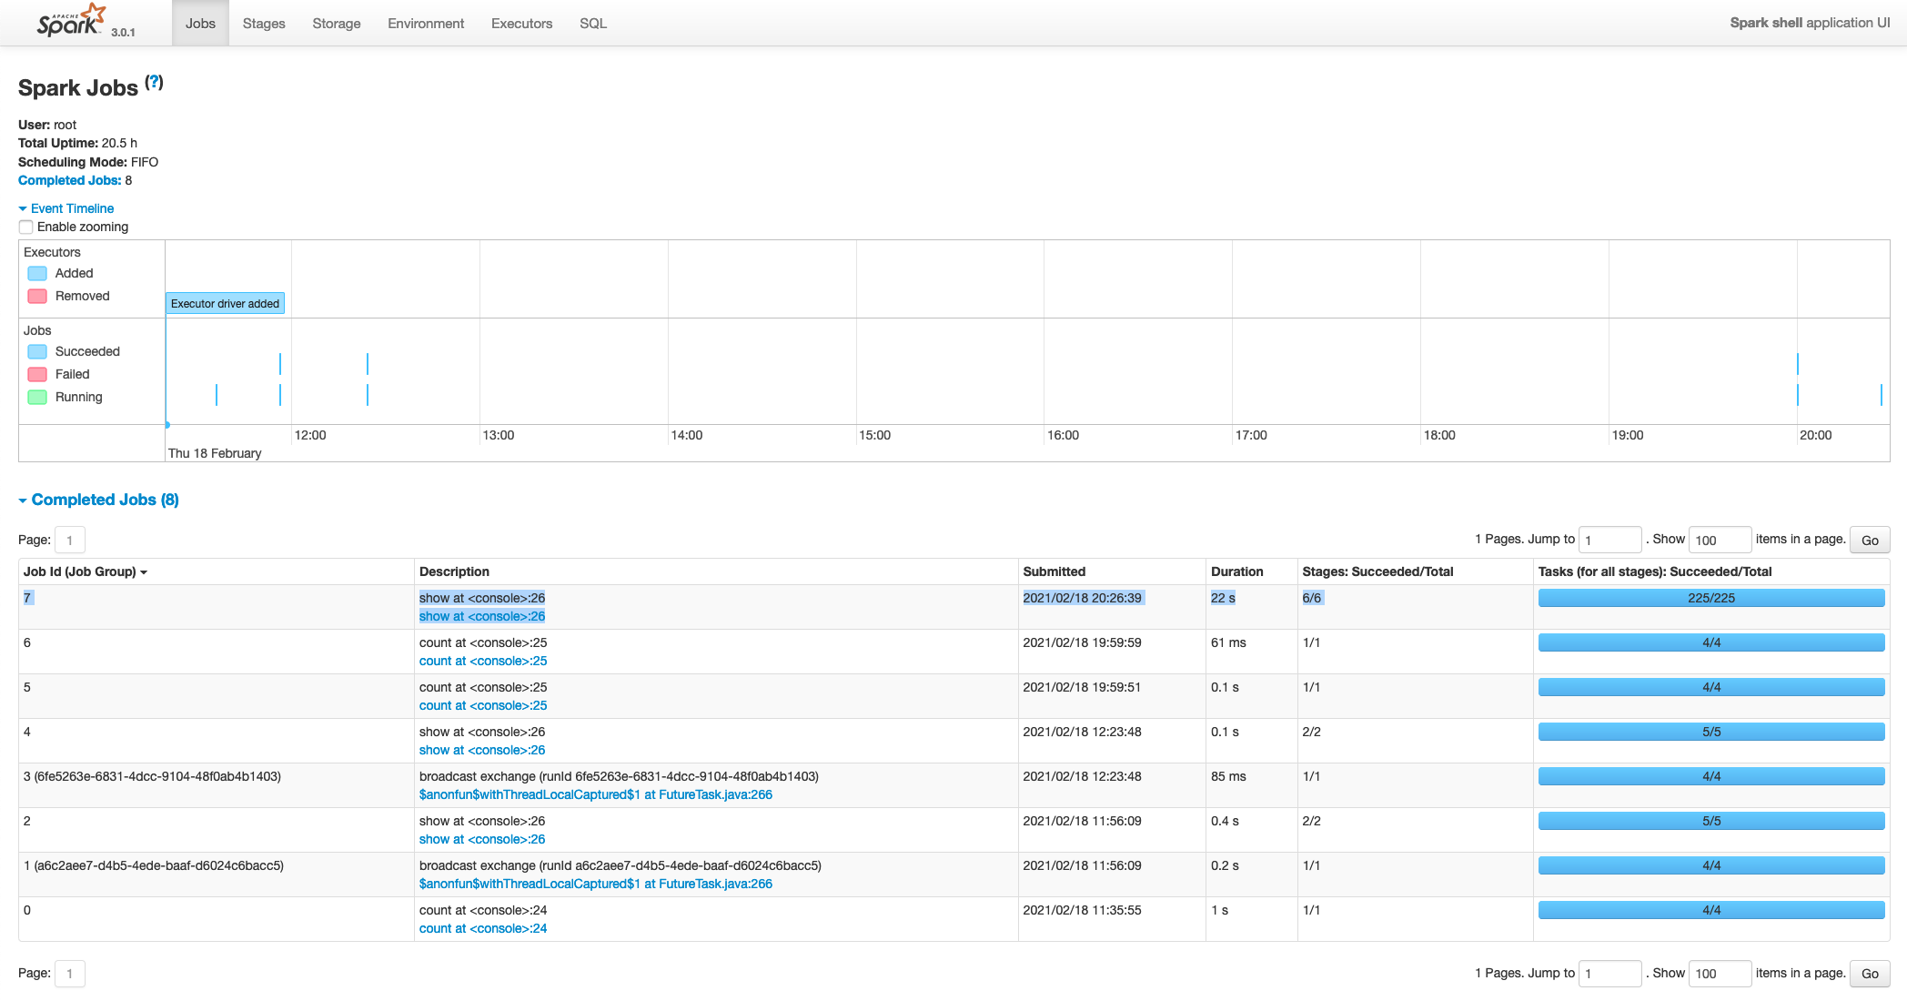

### DAGs or Stages

* Stage ID 13 and 10 are the slow DAGs
* Stage ID 13 ran for 6 seconds with 200 tasks

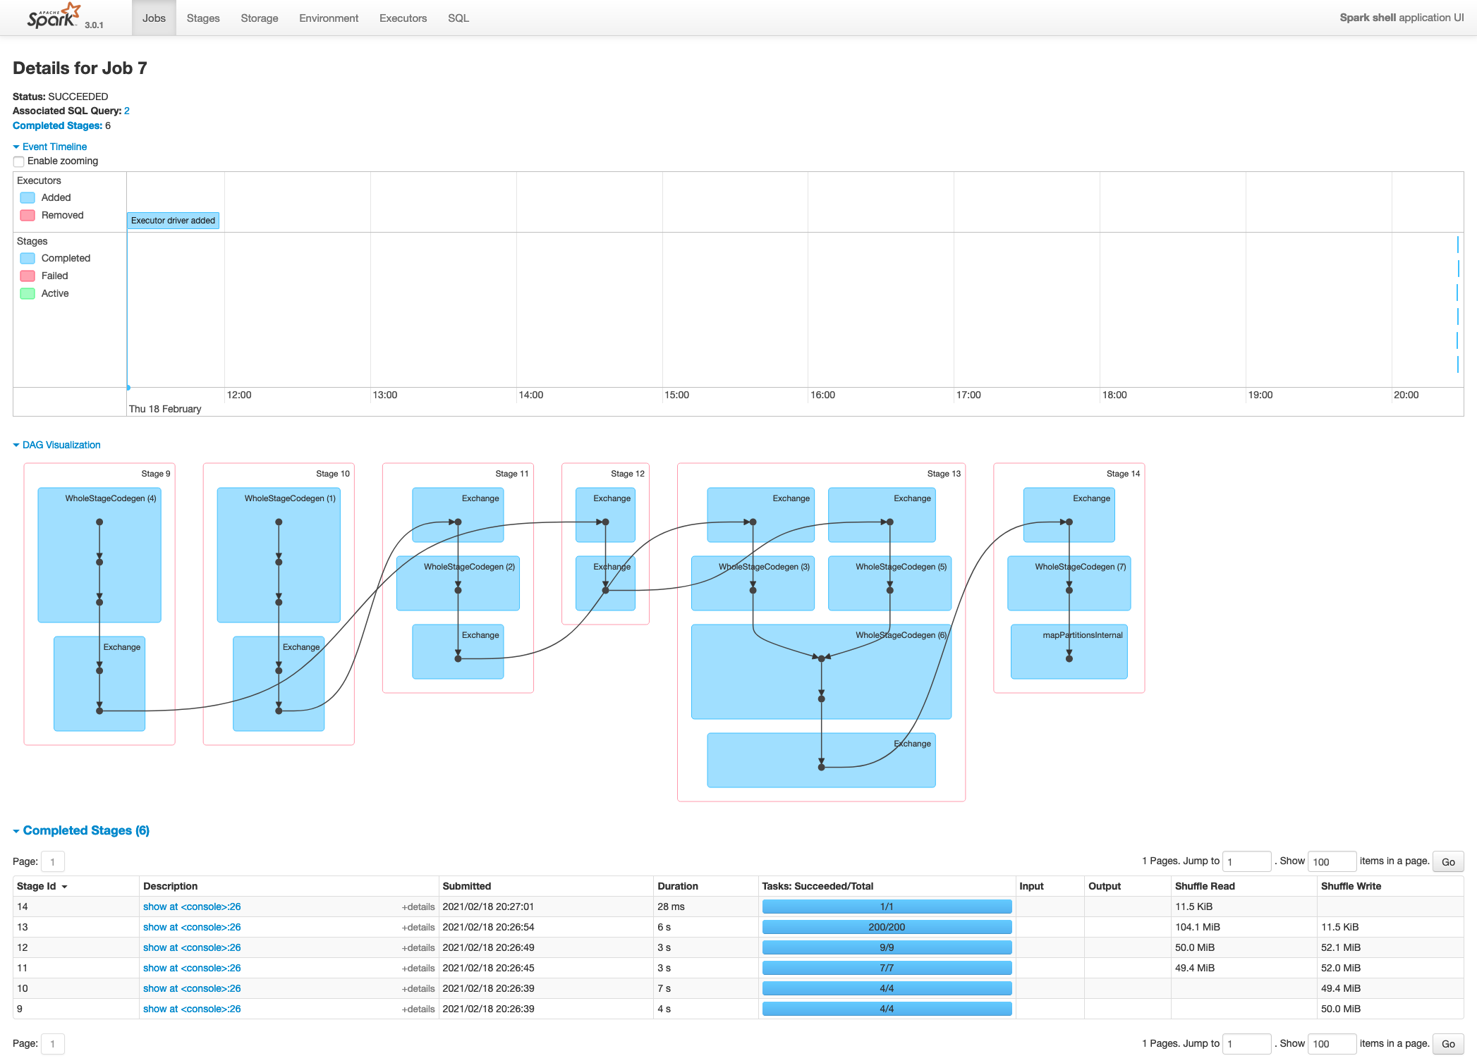

### Tasks

#### Stage 13

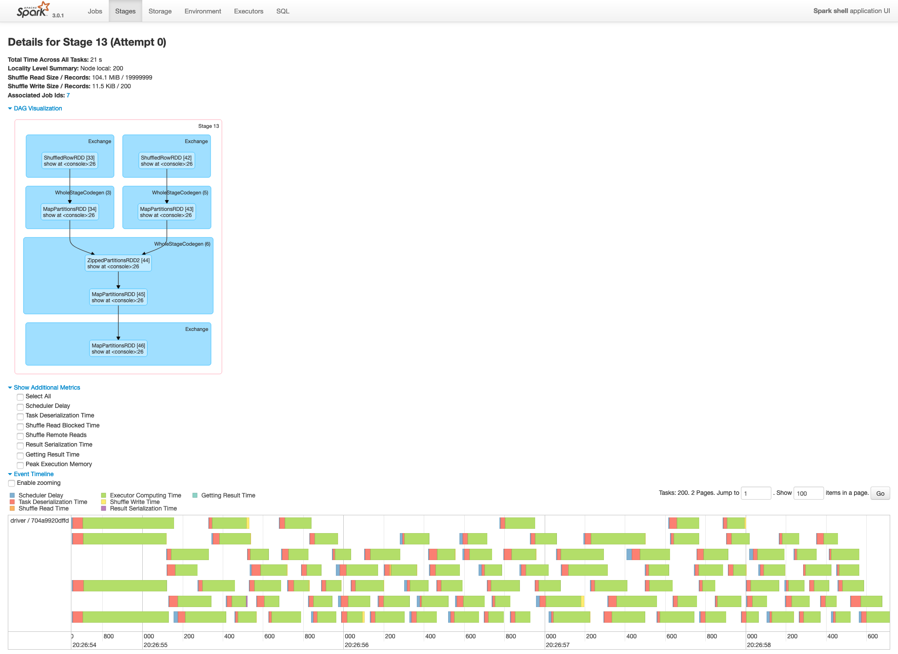

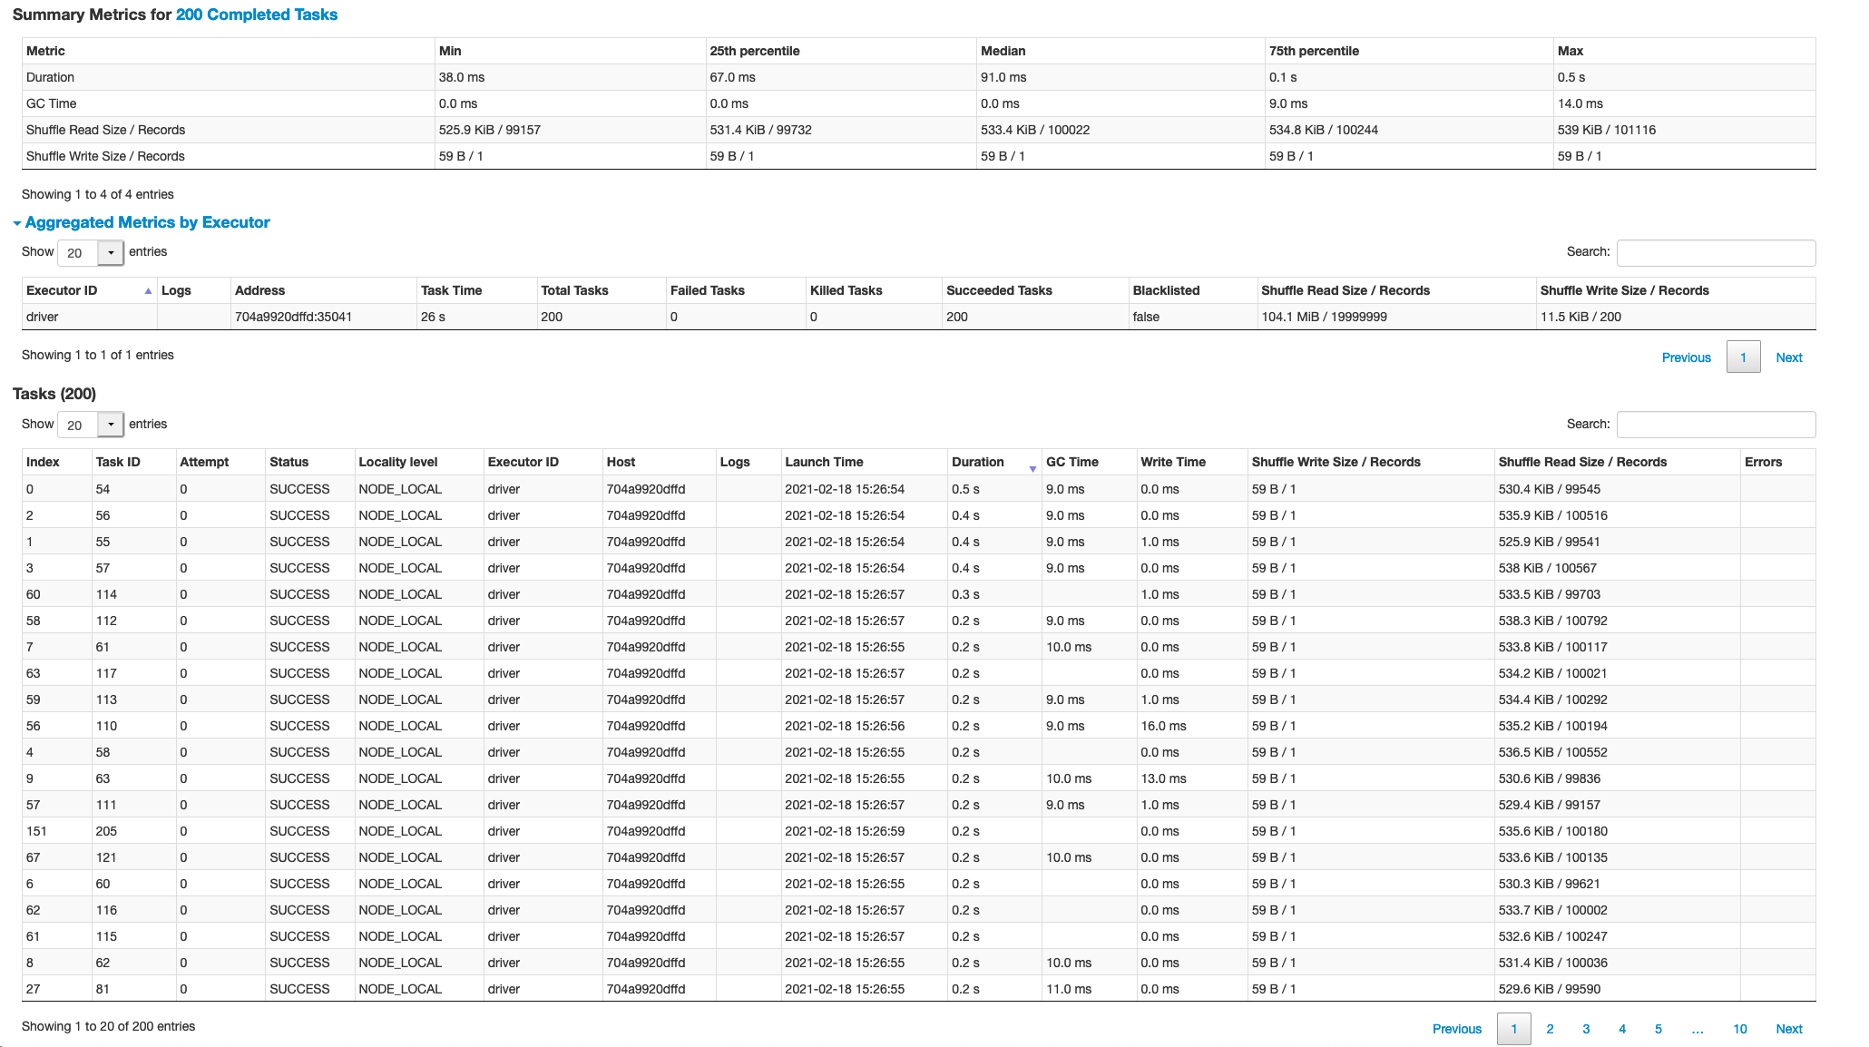

#### Stage 10

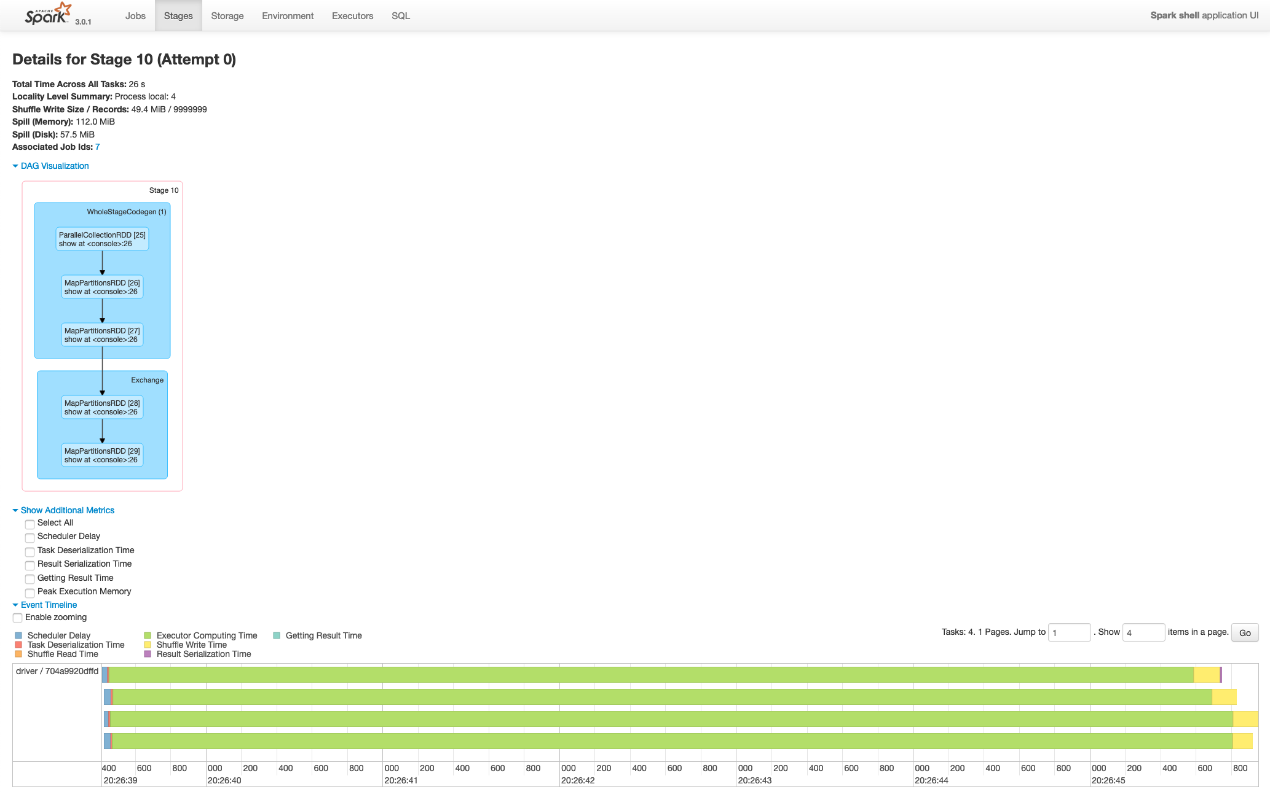

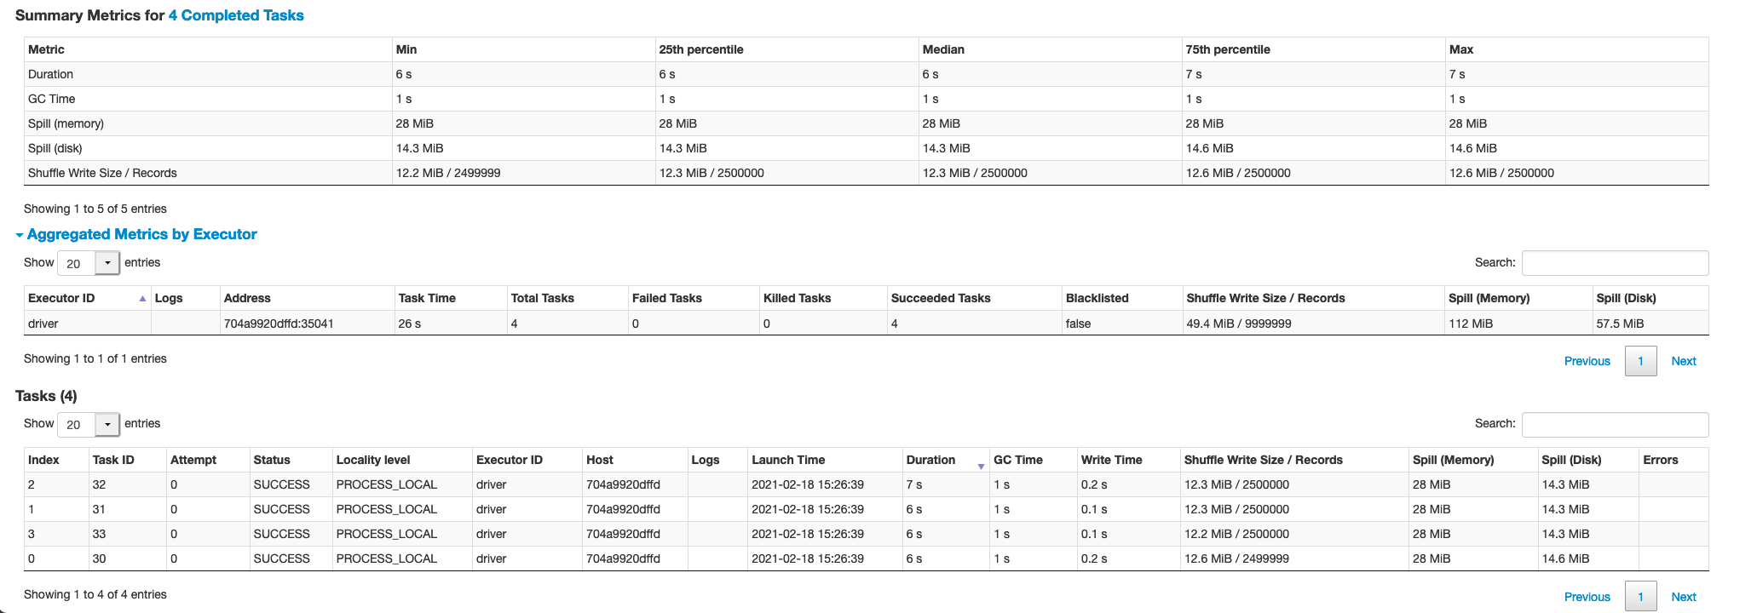

### Stages Summary

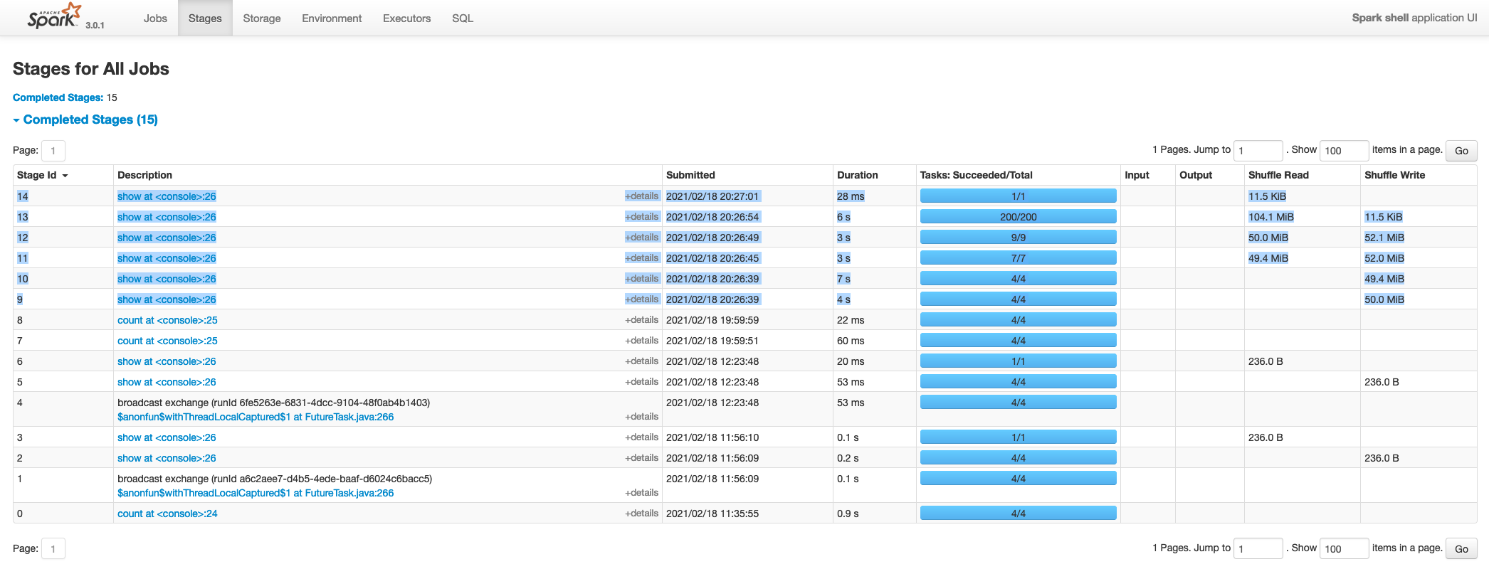

### Storage

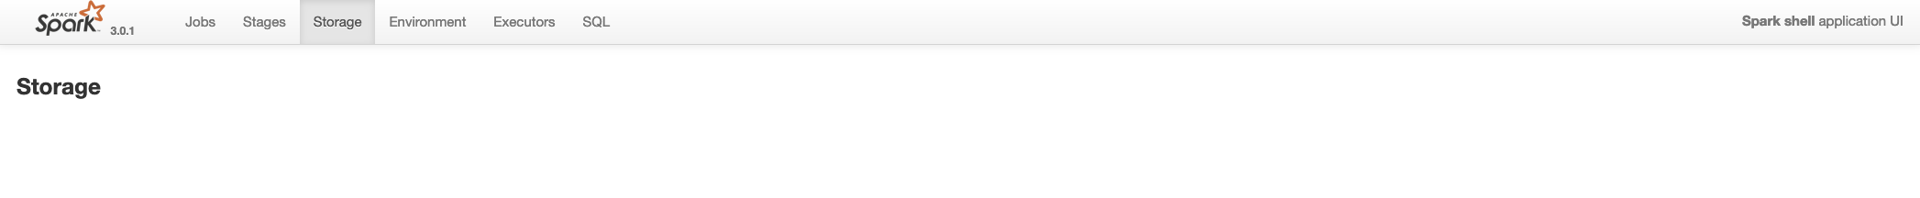

### Environment

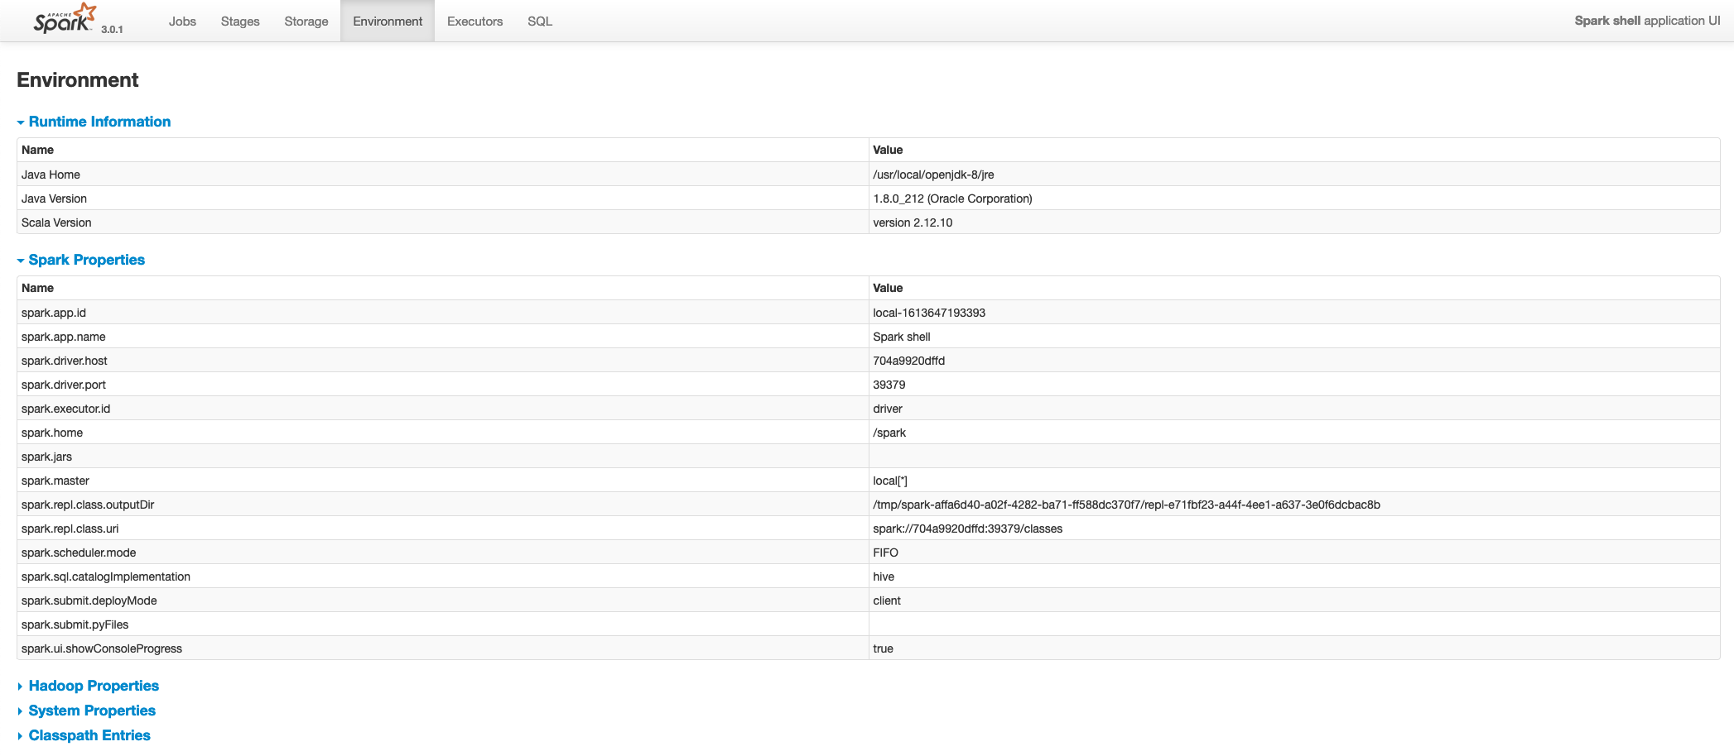

### Executors

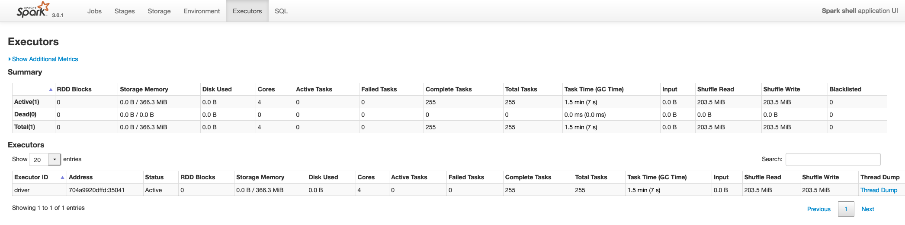

### SQL

#### SQL tab

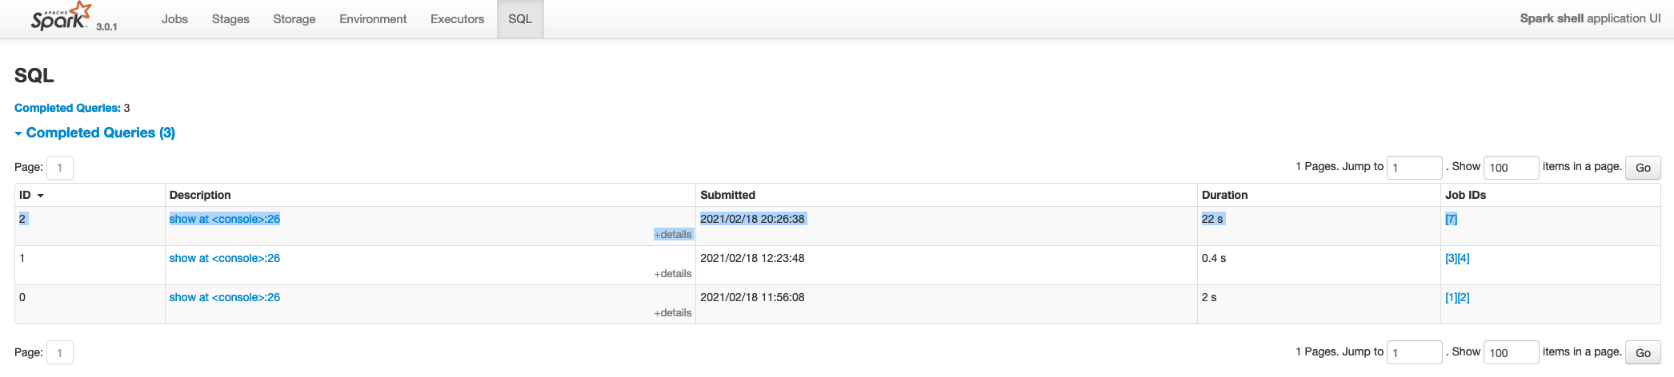

#### Visual and Physical Explain Plan

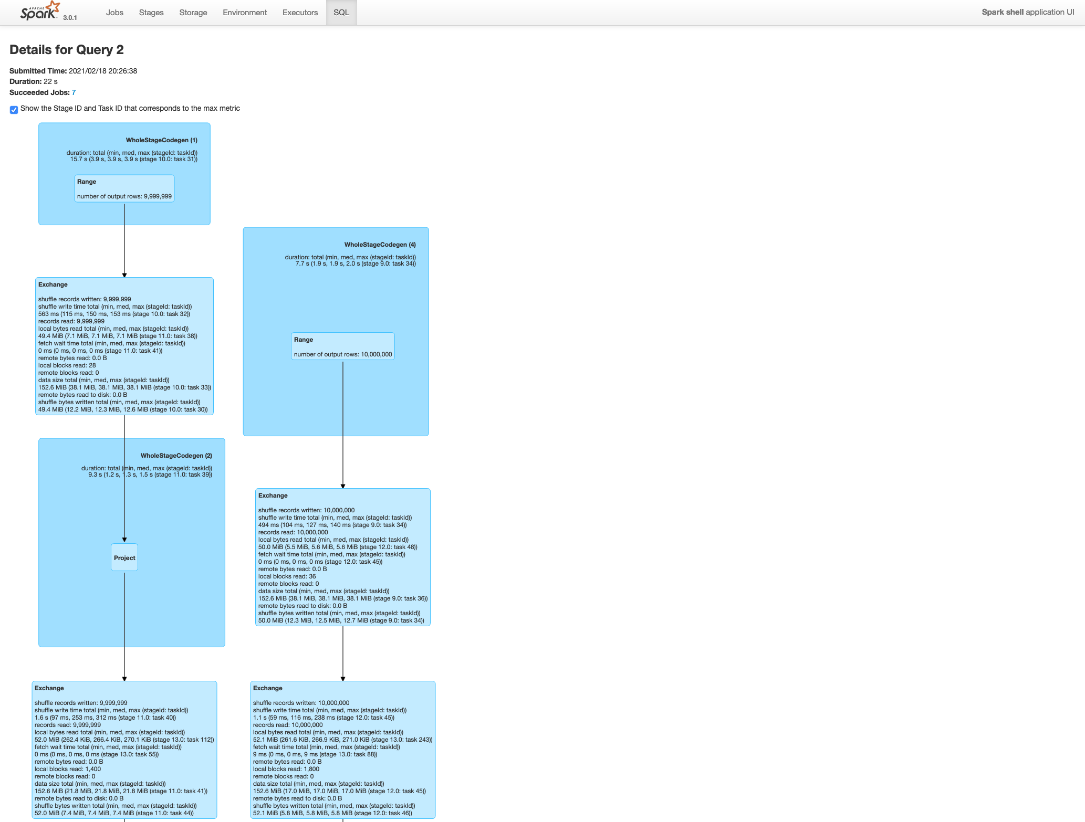

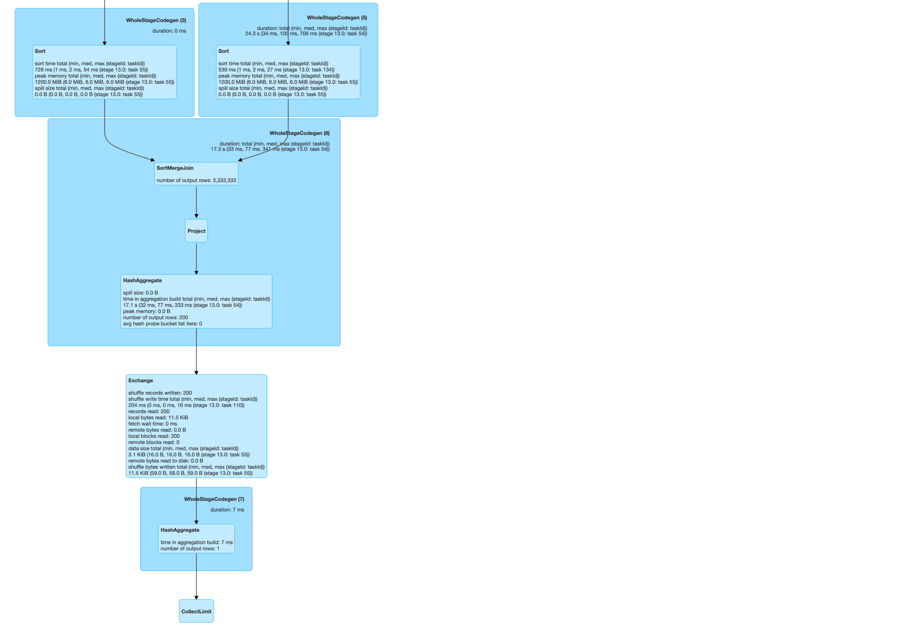

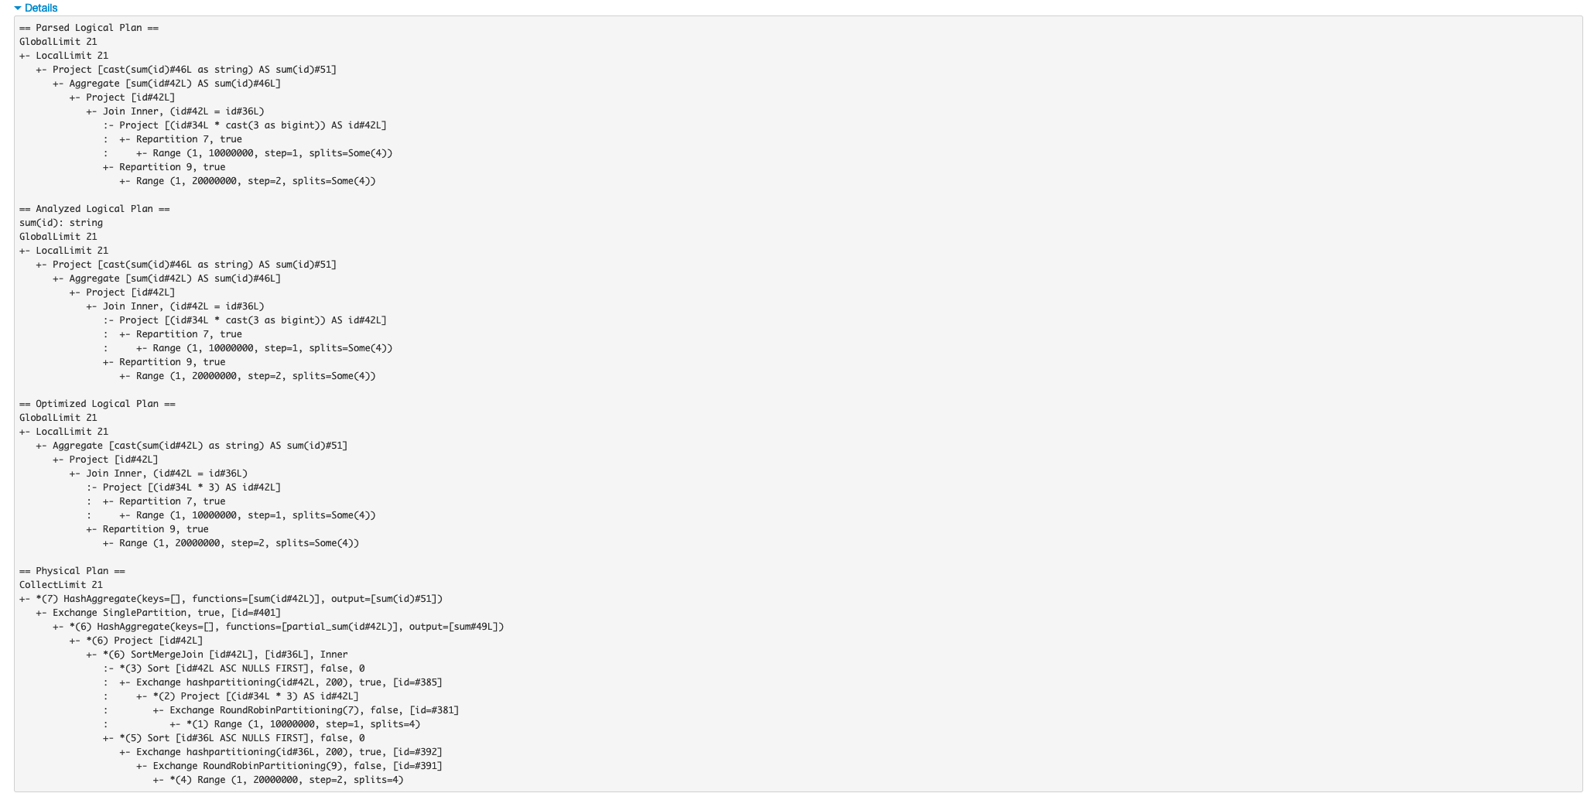

### Correlating the DAG with Visual Explain Plan



